easyPOS
User manual

Содржина
Logging into the system 4
Issuing a fiscal receipt 7
Reversal receipt 11
Reports 14
Shop transaction history 15
Stock list 20
Inventory list report 25
Sales specification 28
Debts and claims 28
Deleted items 34
Евиденција во трговија на услуги 35
Разлика во цени 36
Креирање, модификација и печатење на документи 38
Фактура 40
Испратница 46
Препратница во малопродажба (ПЛТ) 52
Параметрирање 58
Типови на документи 60
Групи на артикли 64
Бар-кодови 66
Лагер 67
Начин на плаќање 68
Коминтенти 69
Артикли 71
Ценовник 75
Жиро - сметки 77
Единици мерки 79
Корисници 81
Магацини 82
Фирма 83
Типови на цени 84
Принтер 85

Logging into the system
Every user needs to log on by entering his username and password in the corresponding fields.
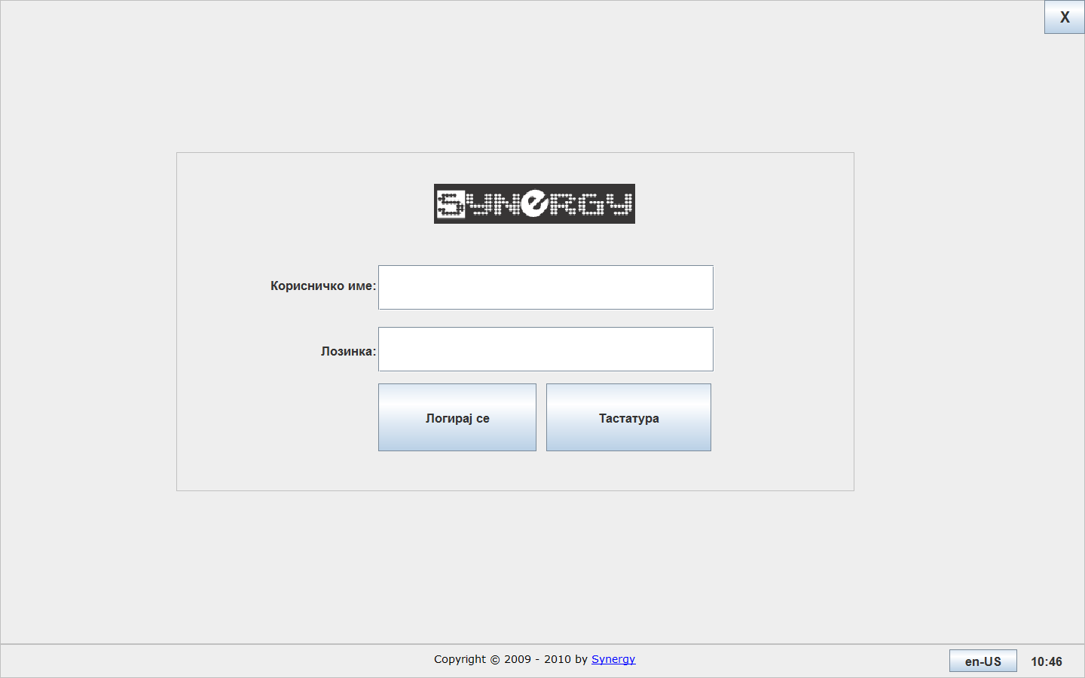
You can use the on-screen keyboard if you don’t use a physical one by pressing 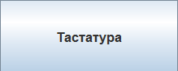
Default username and password:
User name: 1
Password: 1
It is recommended after the first logon, the default credentials to be changed so unauthorized logging in with administrative privileges can be evaded.
The on-screen keyboard looks like this:
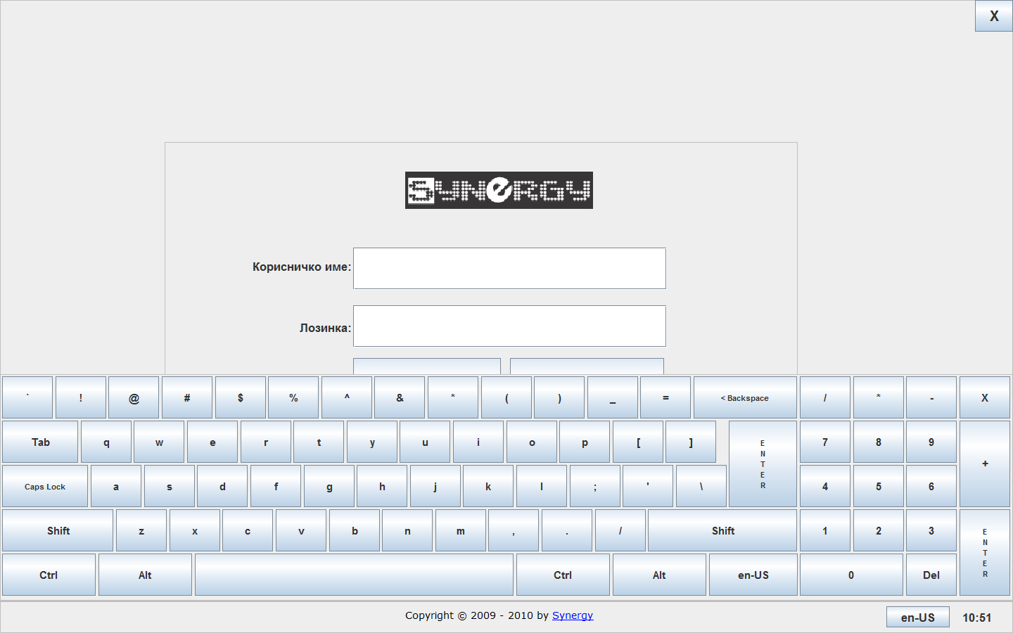
Press 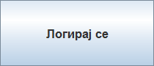 to log into the system.

After successfully logging in the default screen is shown where you can issue fiscal receipts.
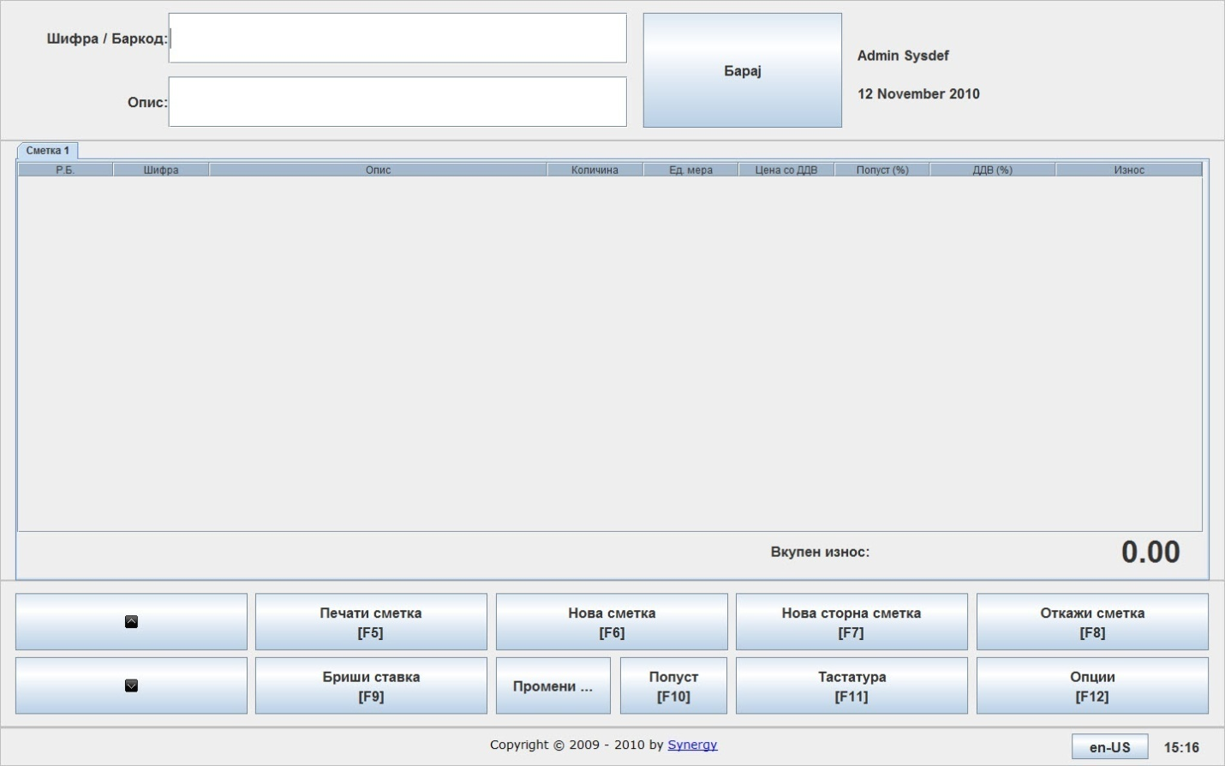

Issuing a fiscal receipt
In order to issue a fiscal receipt, you need to choose the item by typing in the code or description or by using a barcode scanner. You can also use a balance scale with a barcode printer embedded so by reading the barcode the item and its weight are entered in the same time. If you don’t choose the code or description manually you can press Enter and a stock list will be displayed so you can choose an item visually.

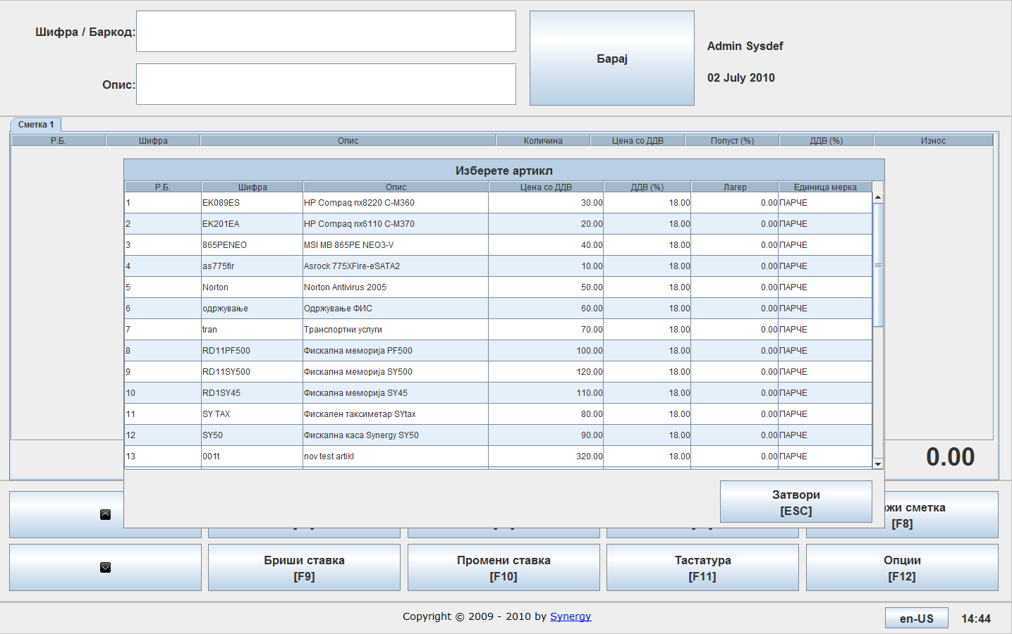

You select the needed item and it is added to the item list.
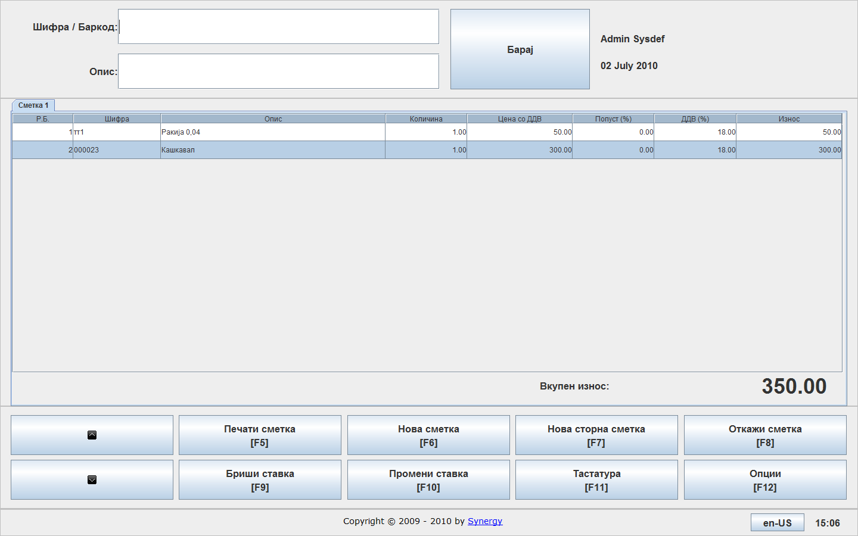
If you want to change a chosen item, click and a new dialog is displayed where you can choose a new quantity or a price discount.
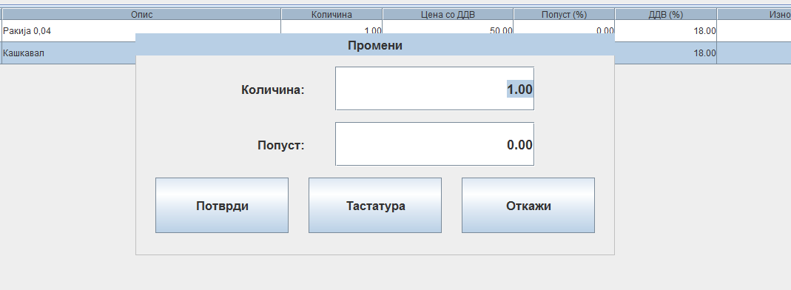
Changes are being applied by pressing 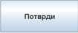 or by pressing Enter with the keyboard.
You can delete an item by pressing 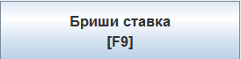 after which you need to confirm you want to delete the chosen item.
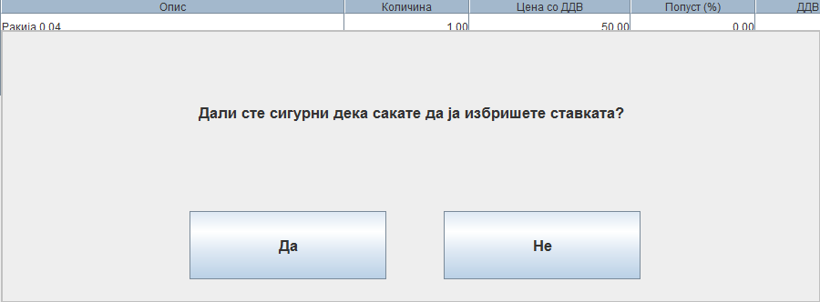
You can print the fiscal receipt by pressing after which the following dialog appears:
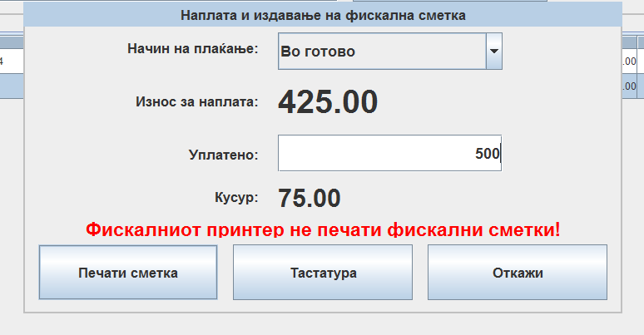
You can write down the cash amount the customer pays in this field

easyPOS offers the option to create a new receipt while working with current one simultaneously by pressing , after which the new receipt is created in a new tab. This receipt can be printed by pressing or by pressing F5 with the keyboard.
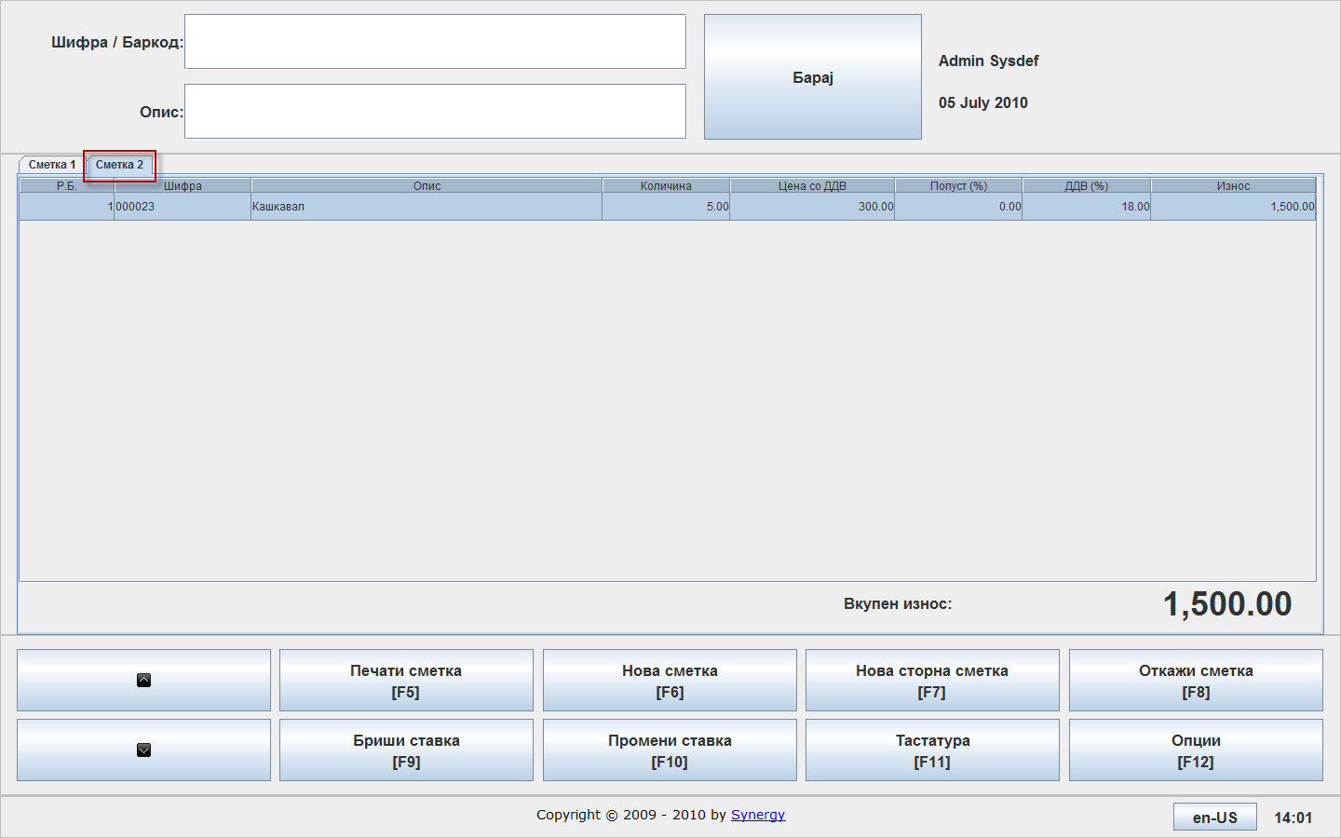

Void receipt
Void receipt can be created in the following manners:
- By entering the item that needs to be canceled
Canceling only the item that needs to be canceled. This is done by pressing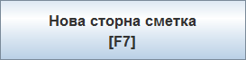 or by pressing F7 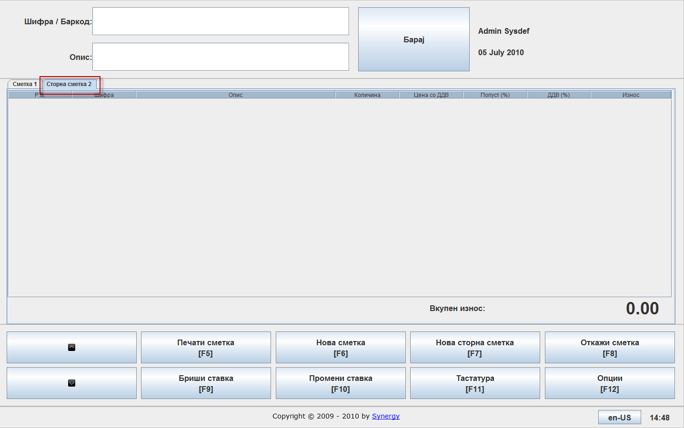
In the field or the item that needs to be canceled is entered.
If you don’t know the exact item code you can search for the item from the list by pressing Enter.

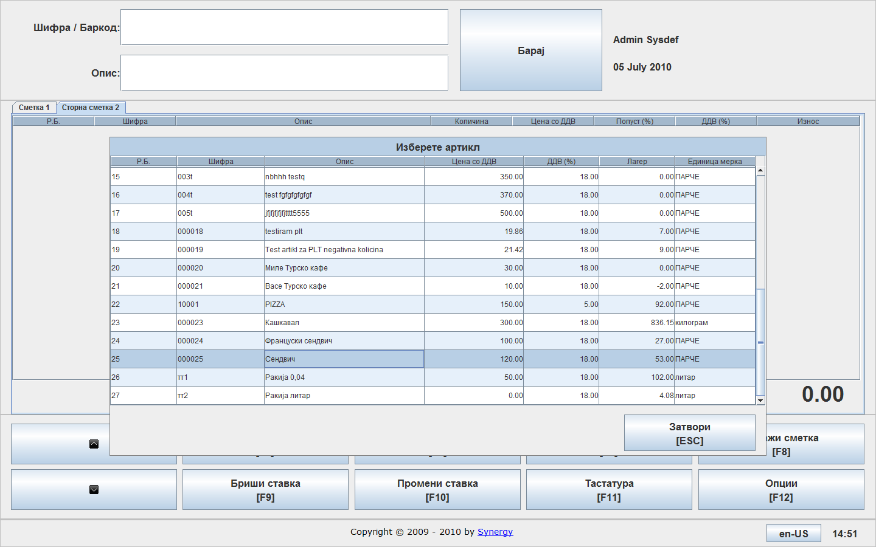
The needed item is being chosen, quantity entered and by pressing 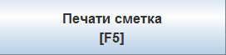 the void receipt is printed.

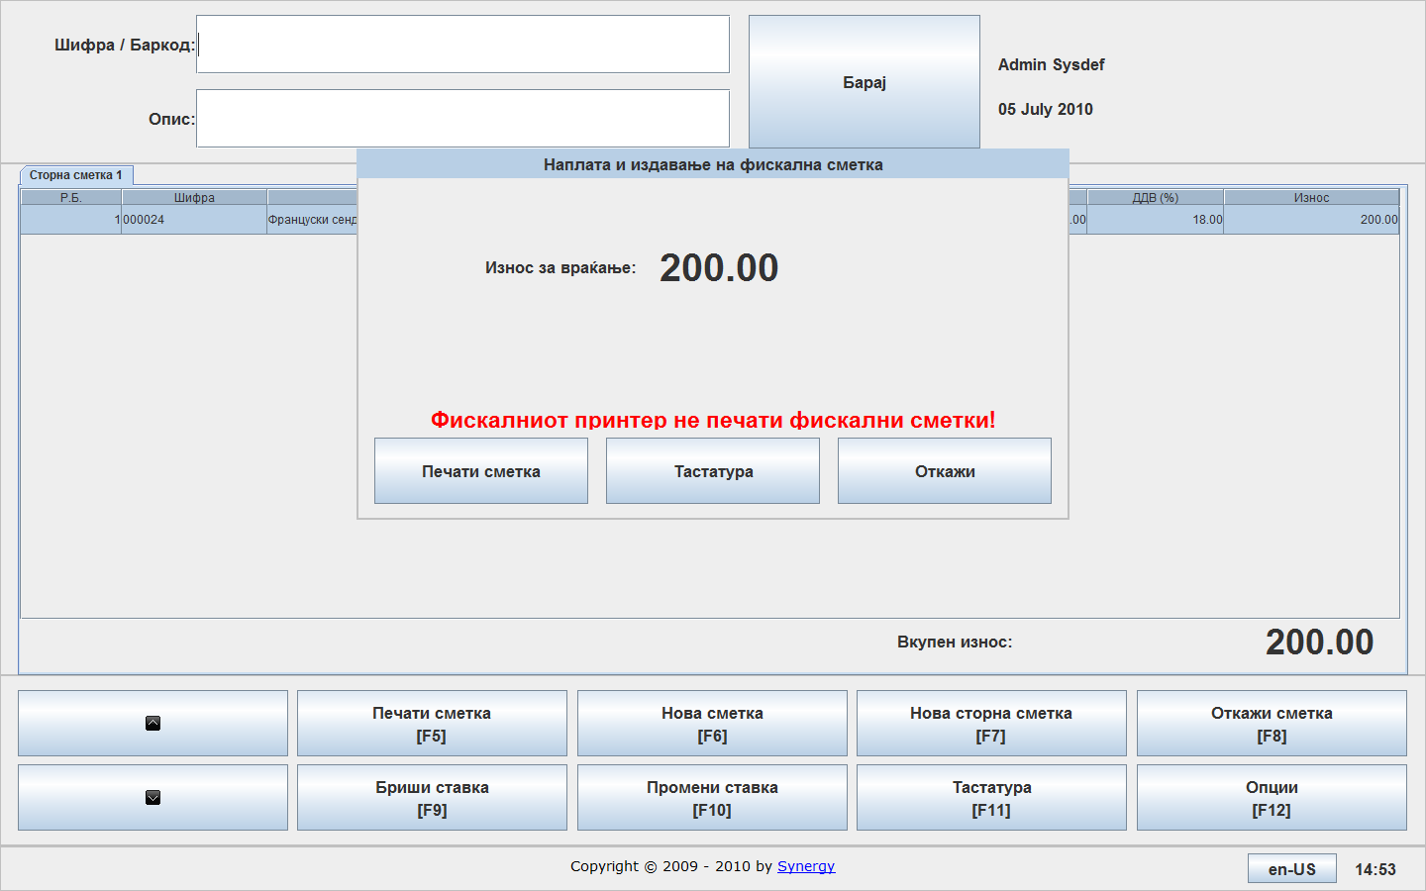
By pressing the void receipt is confirmed.
- Receipt cancelation
If the customer decides to cancel the receipt during purchasing, you can cancel it by pressing 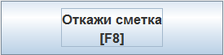, or F8 after which you need to confirm the cancelation.
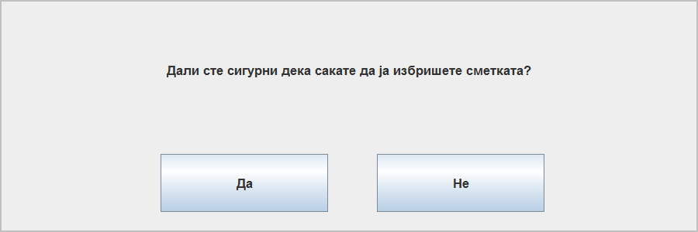

Reports
You can access the standard reports by pressing or F12, after which the following screen appears where you need to choose Reports:
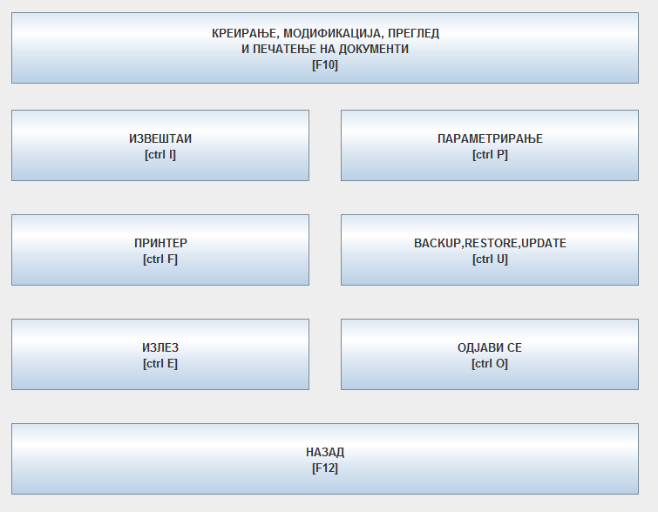
By choosing Reports you will get the Report list where you can choose the desired report. The reports are explained next.

Shop transaction history

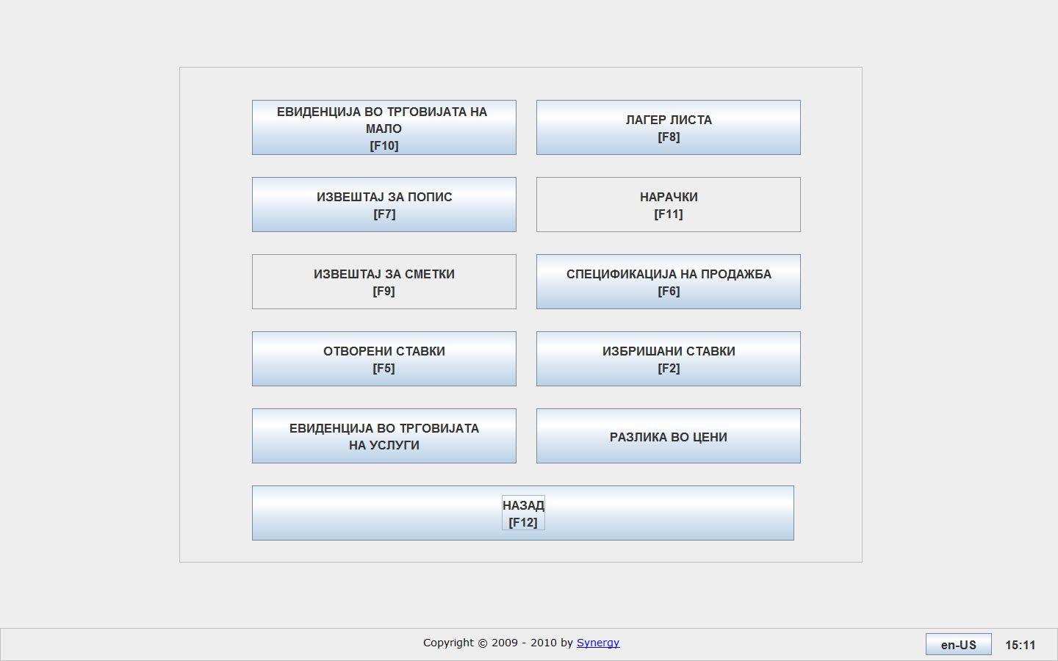
By choosing 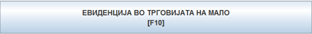 the following screen appears:
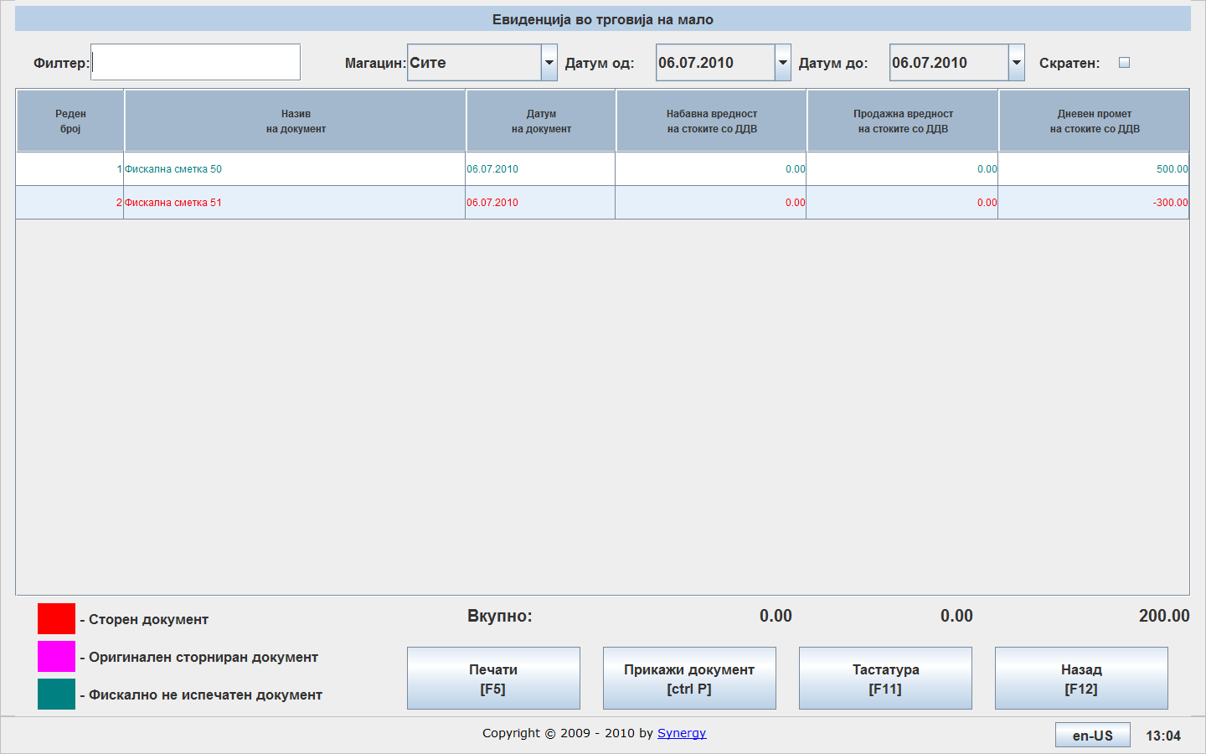
There are few filters available so you can acquire a suitable report. You can choose the needed warehouse by choosing it from the following drop down menu 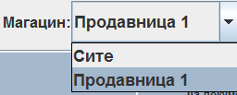
You can choose the time interval by choosing it using the following fields:
By selecting 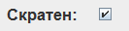 you can get a summarized report.

For example:
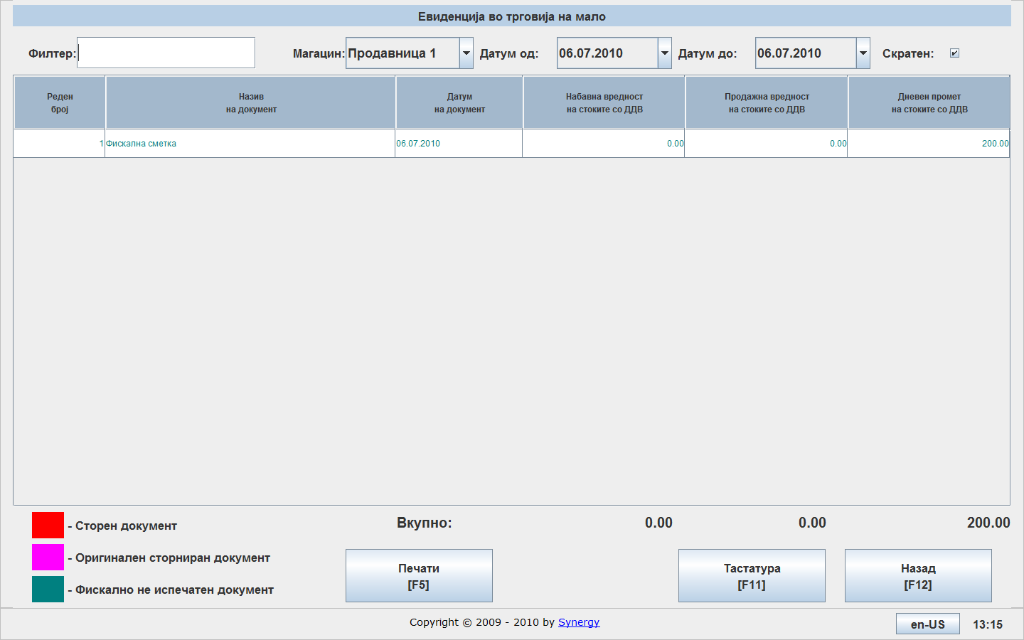
By pressing you can print the report:
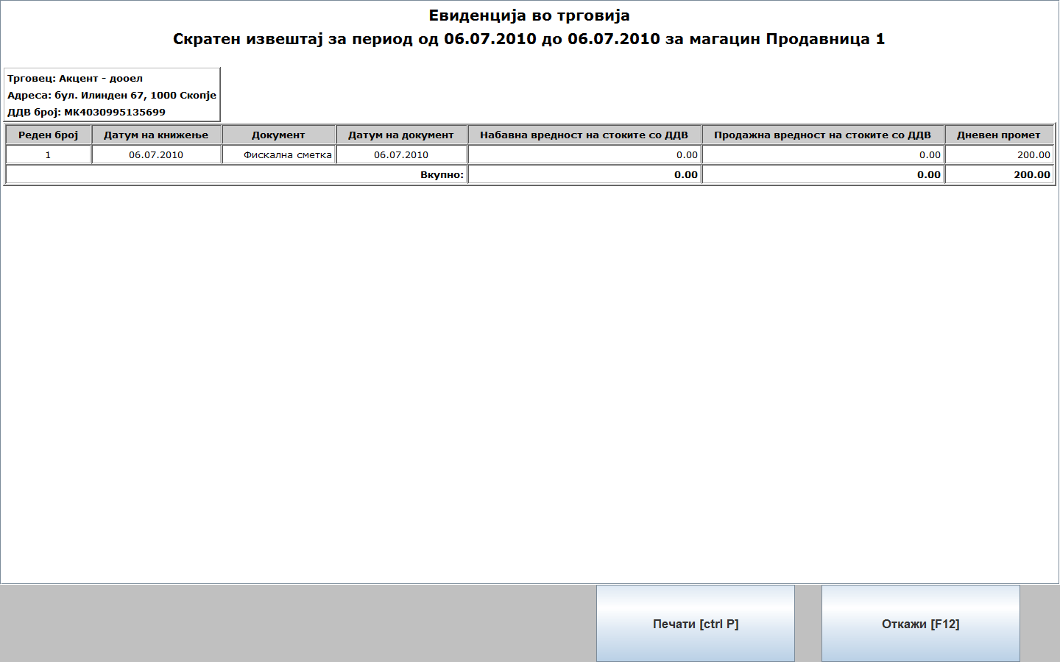
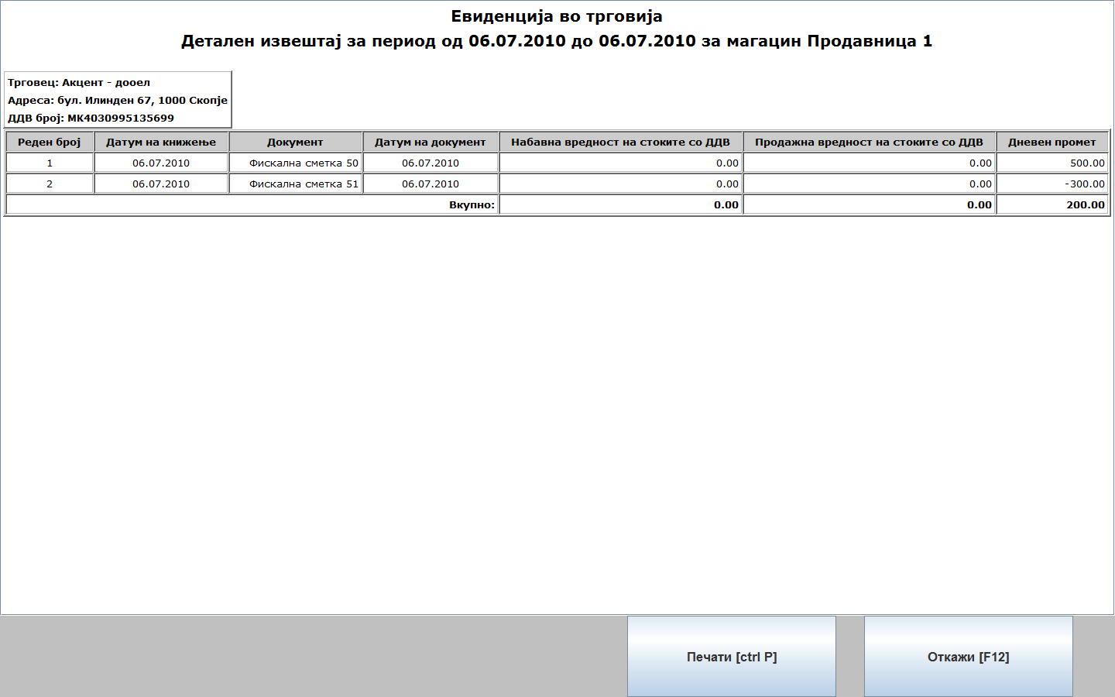
By selecting the fiscal receipt and clicking 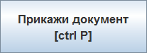, you can print a printed non-fiscal receipt if some customer asks for one:
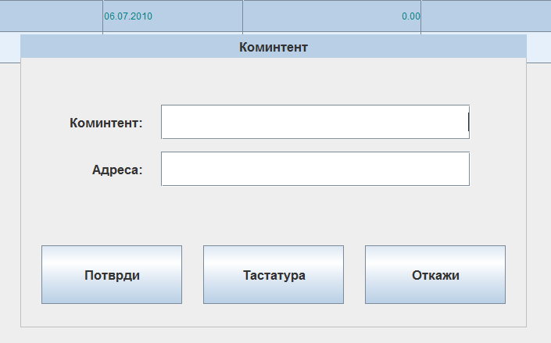
In this screen you can enter the customer’s name and address since this information is obligatory for non-fiscal printed receipt.
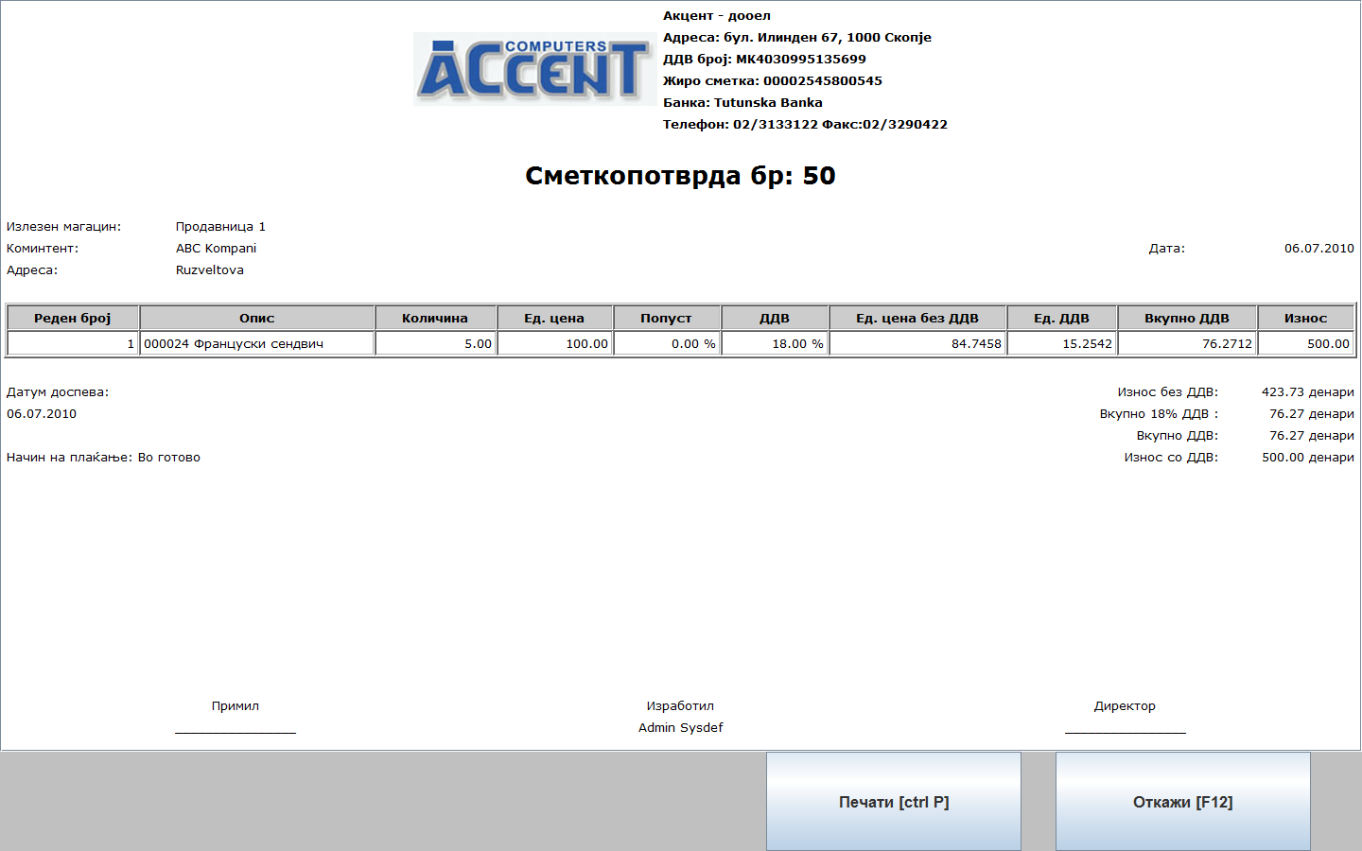
By pressing 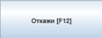 you can exit the Shop transaction history report.

Stock list

By choosing the report Stock list by pressing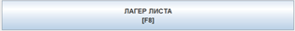, you can get the amount of stock you have in the moment.
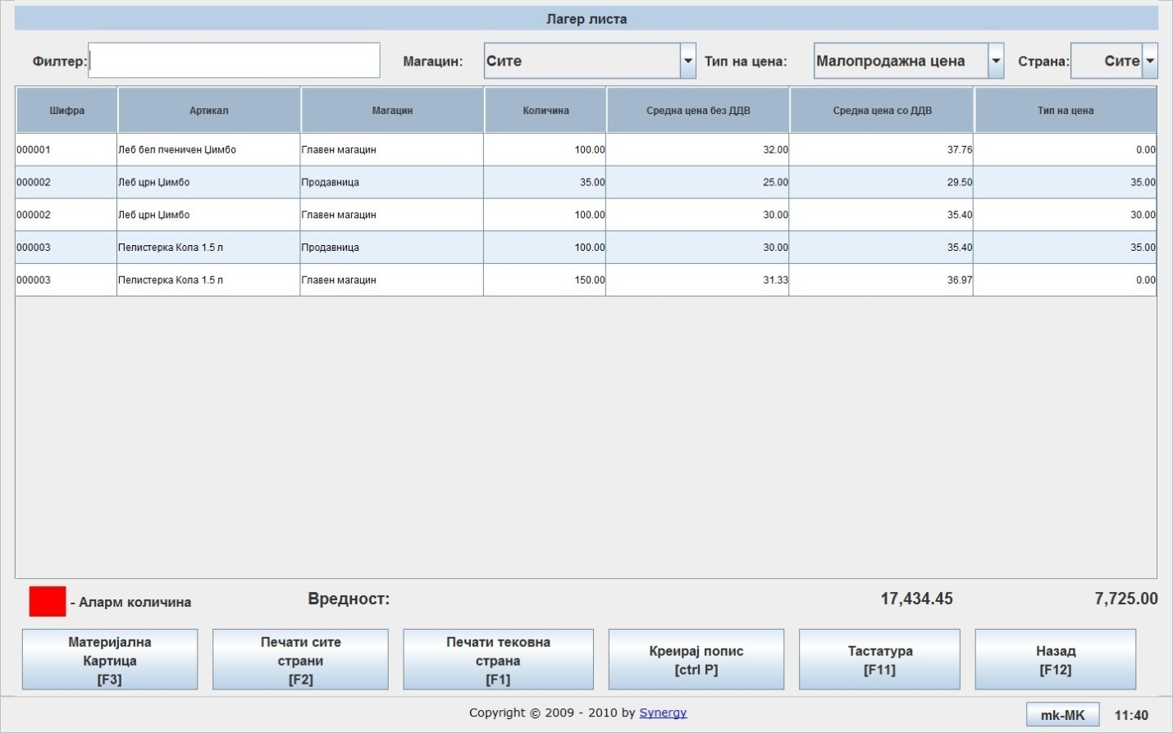
You can choose the needed warehouse as well as the type of price. Here you can view an Item journal for the selected item by pressing 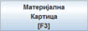
By pressing 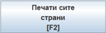 you ca print the entire stock list (all pages) or you ca print the current page by pressing 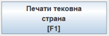
The Item journal looks as follows:
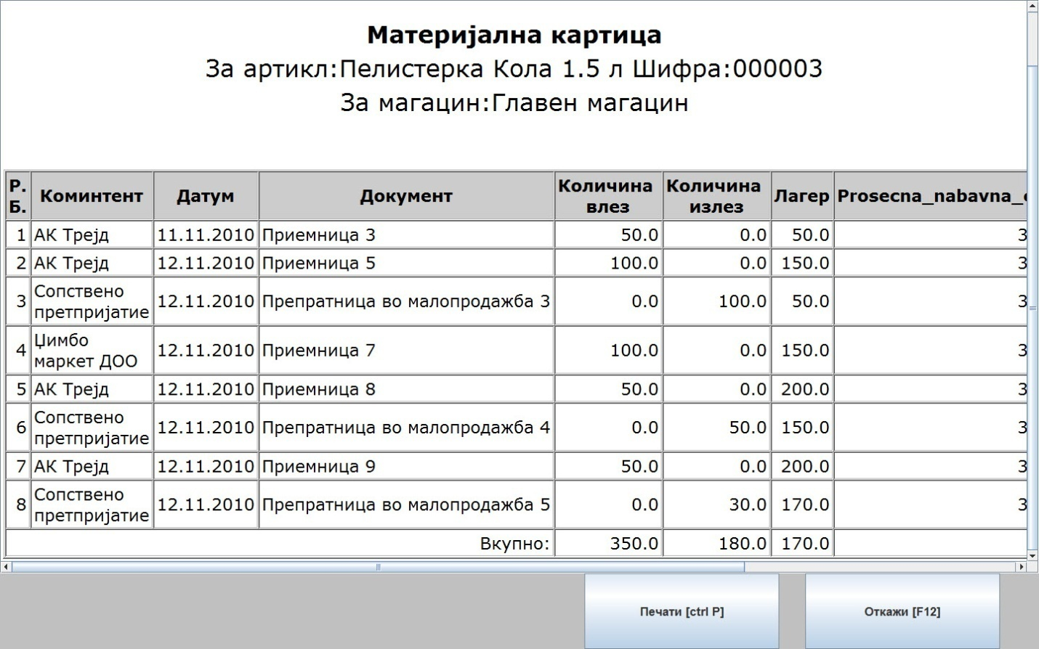

You can create an inventory list from this menu. You can create the inventory list by choosing the needed warehouse, then the price type and press 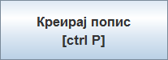. After creating the inventory list you can enter the exact stock as counted. easyPOS will level the stock difference but first you need to Align the inventory which is described next.
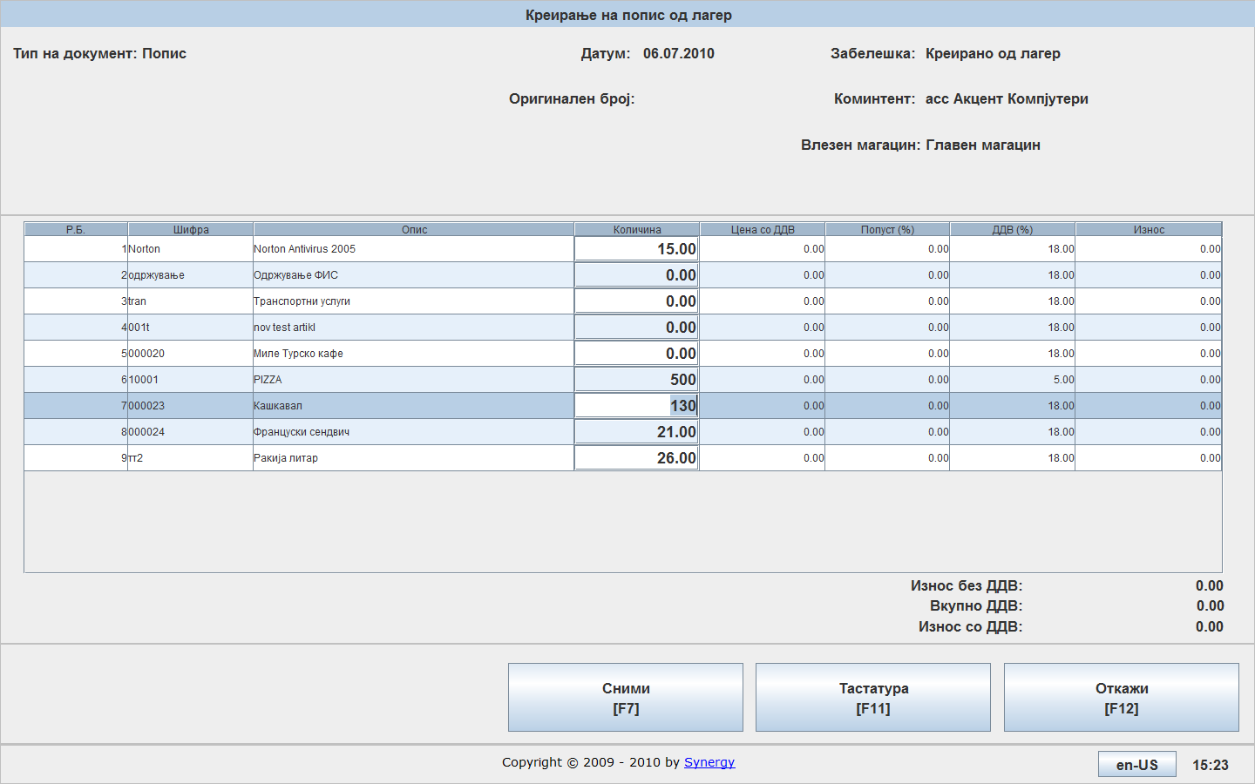
The stock list is saved by pressing 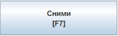. You have the option to confirm saving the stock list.
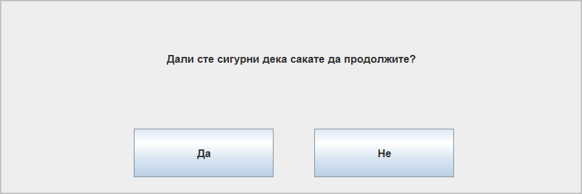

Inventory list report

By pressing 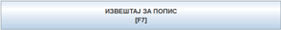 you are choosing the Inventory list report.
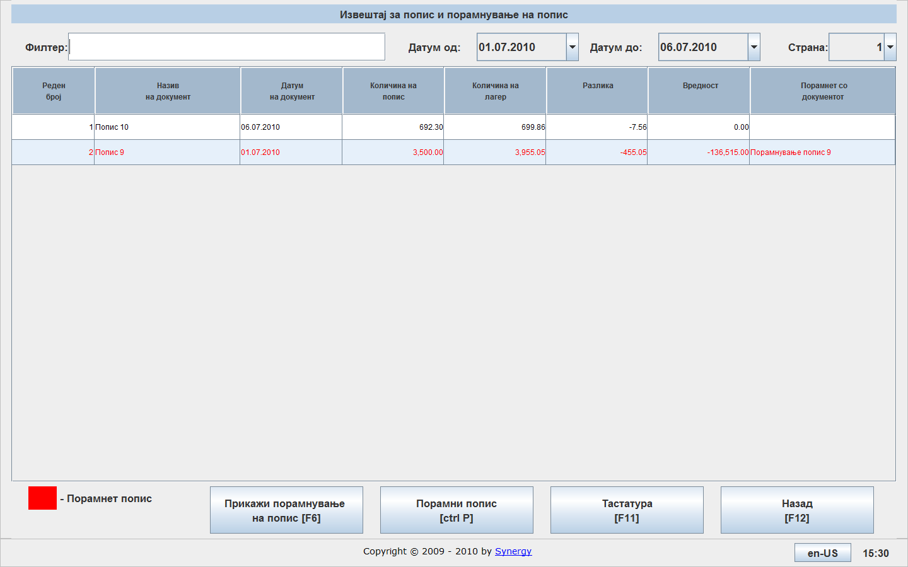
On the above screen an inventory list is displayed containing two inventory lists of which one is aligned and one is not. To align the inventory list you need to select it and press 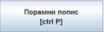.
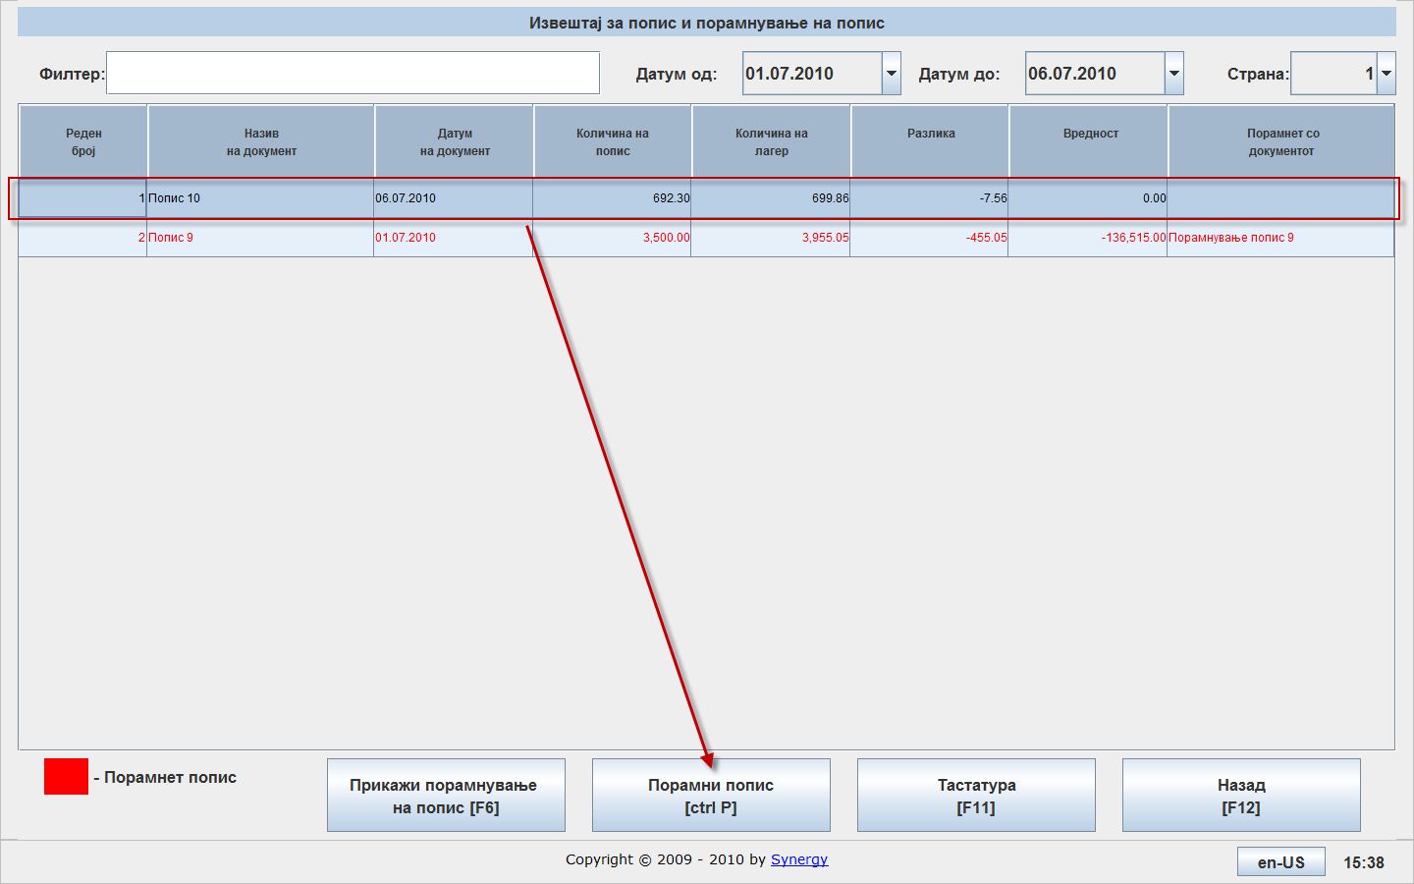
After the confirmation, the aligning is finished.
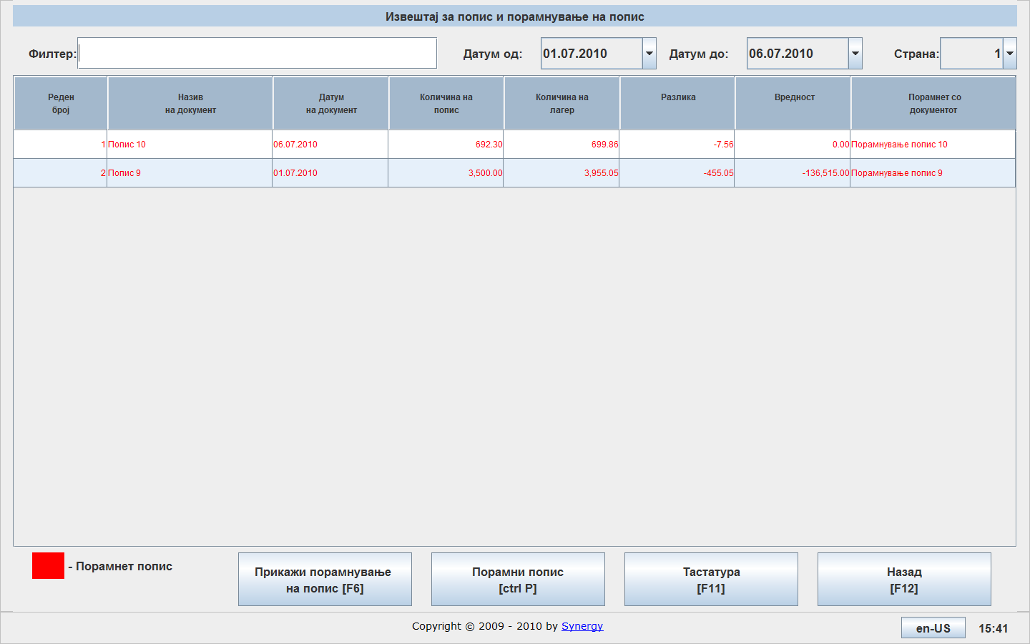
By pressing 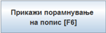 you can view the aligned inventory list as follows:
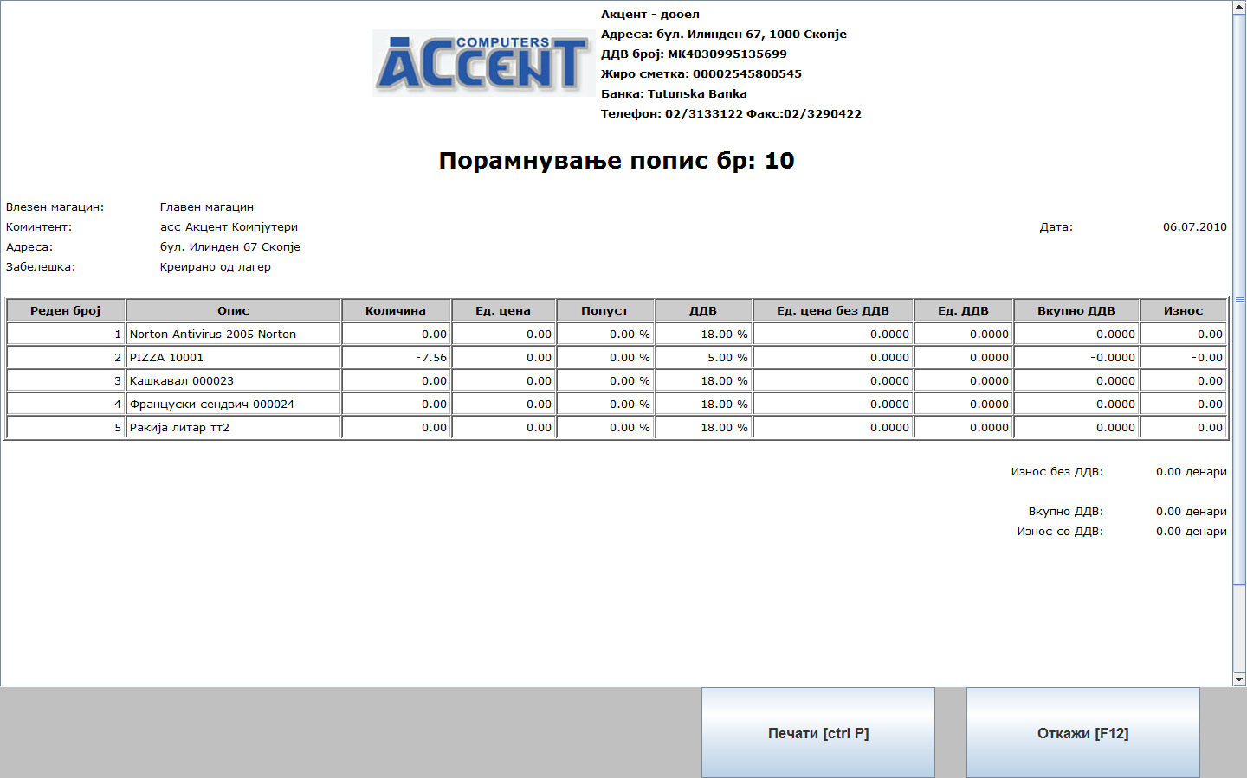

Sales specification

By pressing 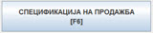 you can get a specification of sales in a certain time interval for every document that made the sale and the certain user.
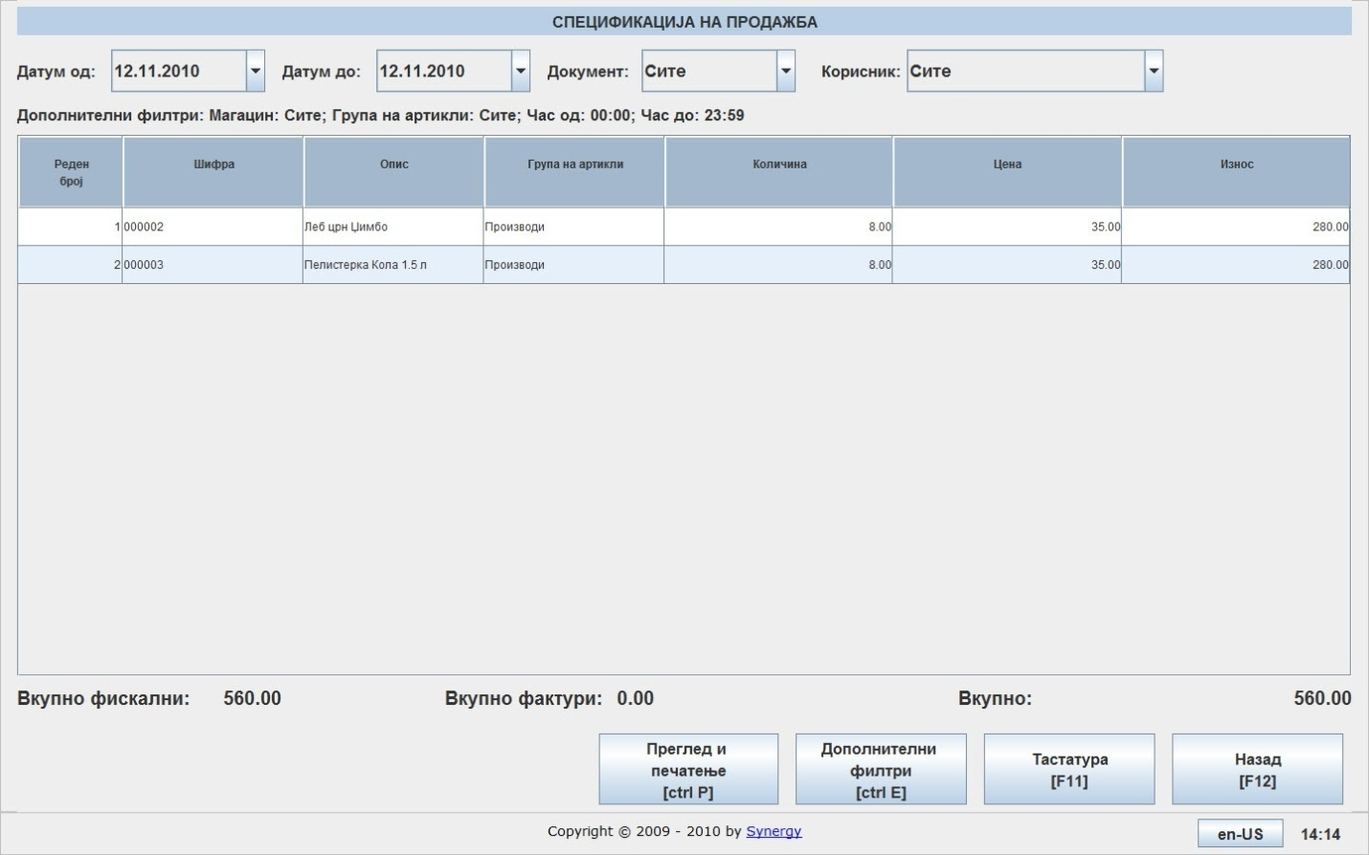

Debts and claims

By pressing you can get a preview of all debts and claims as well as their status. The status can be unpaid, paid and pre-paid.
In this case this report shows a list of incoming and outgoing invoices with corresponding payments and summarizations.
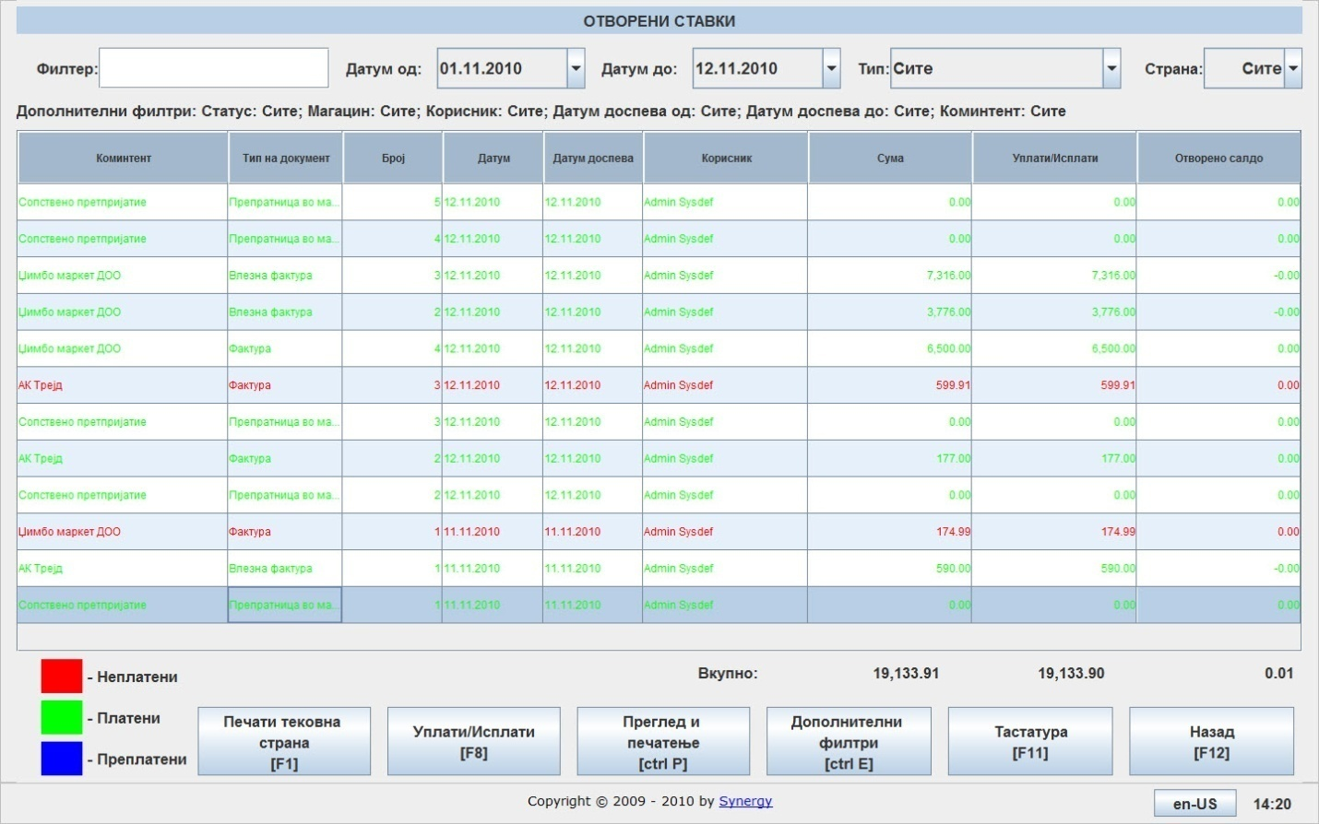

By pressing 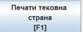 you can print the current page as shown below:
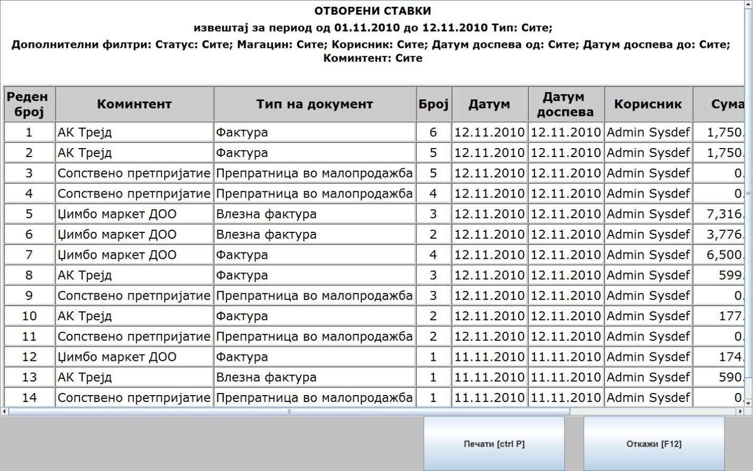
By selecting an invoice and pressing 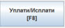 you can enter the amount of payment paid or received for the invoice.
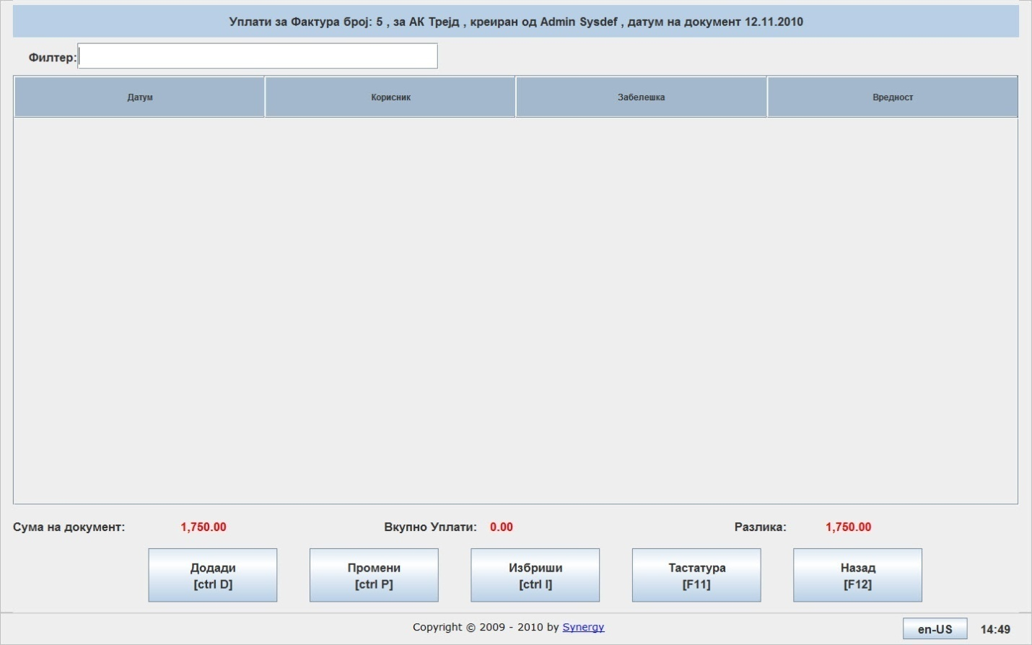
By pressing Add, you can enter payments for the selected invoice.
By pressing Modify, you can change already entered payments.
By pressing Delete, you can delete a selected payment.
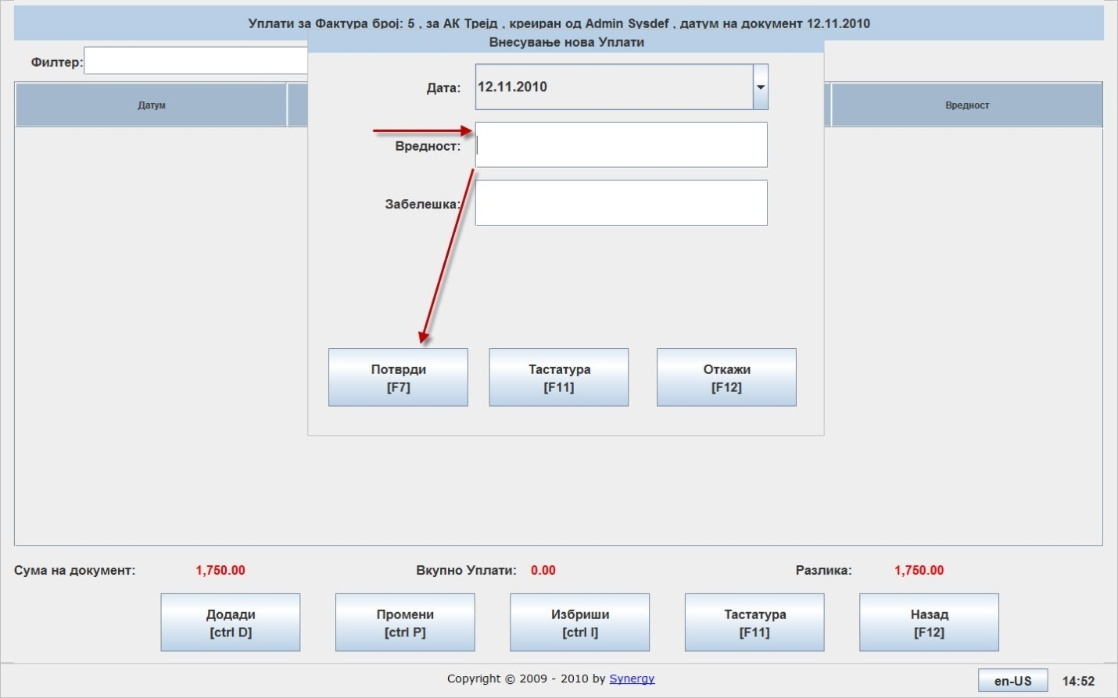
Payments can be complete or partial. This influences the status of the debts or claims.

By pressing 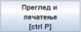 you can get a preview of the selected invoice.

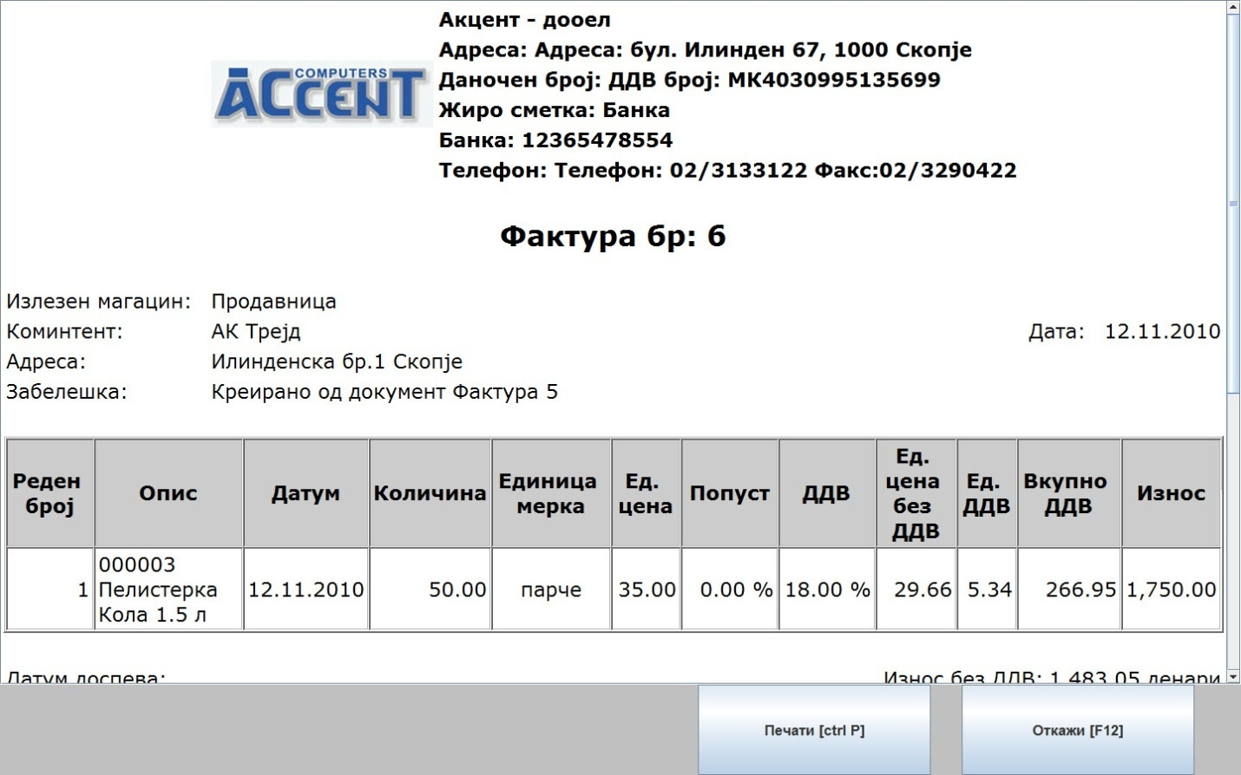
By pressing 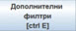 you can preview all invoices filtered by customer’s code or name.
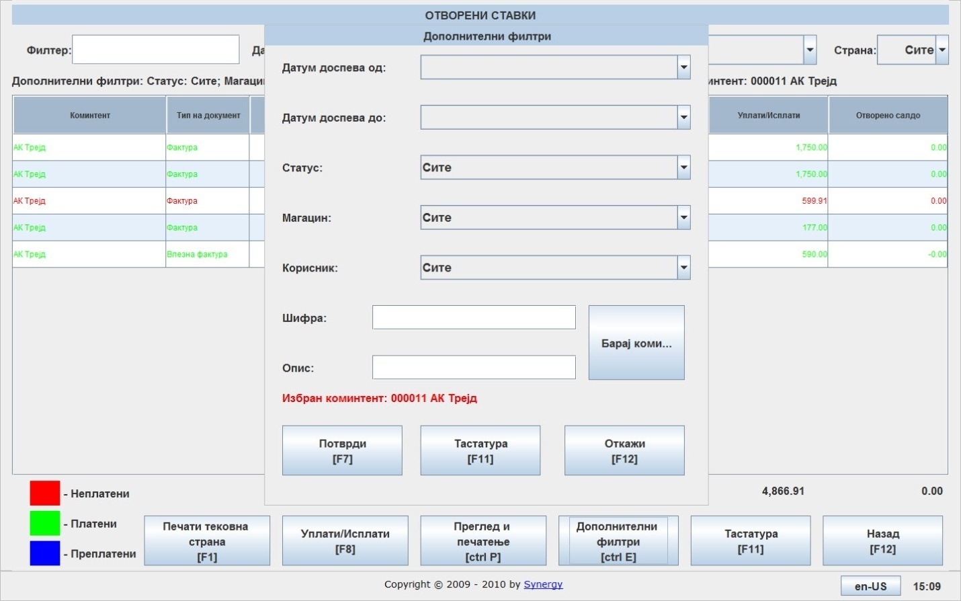

Deleted items

This option serves to show a list of all deleted items, deleted documents as well as deleted item value. The selection can be filtered by time interval and user who deleted the items.
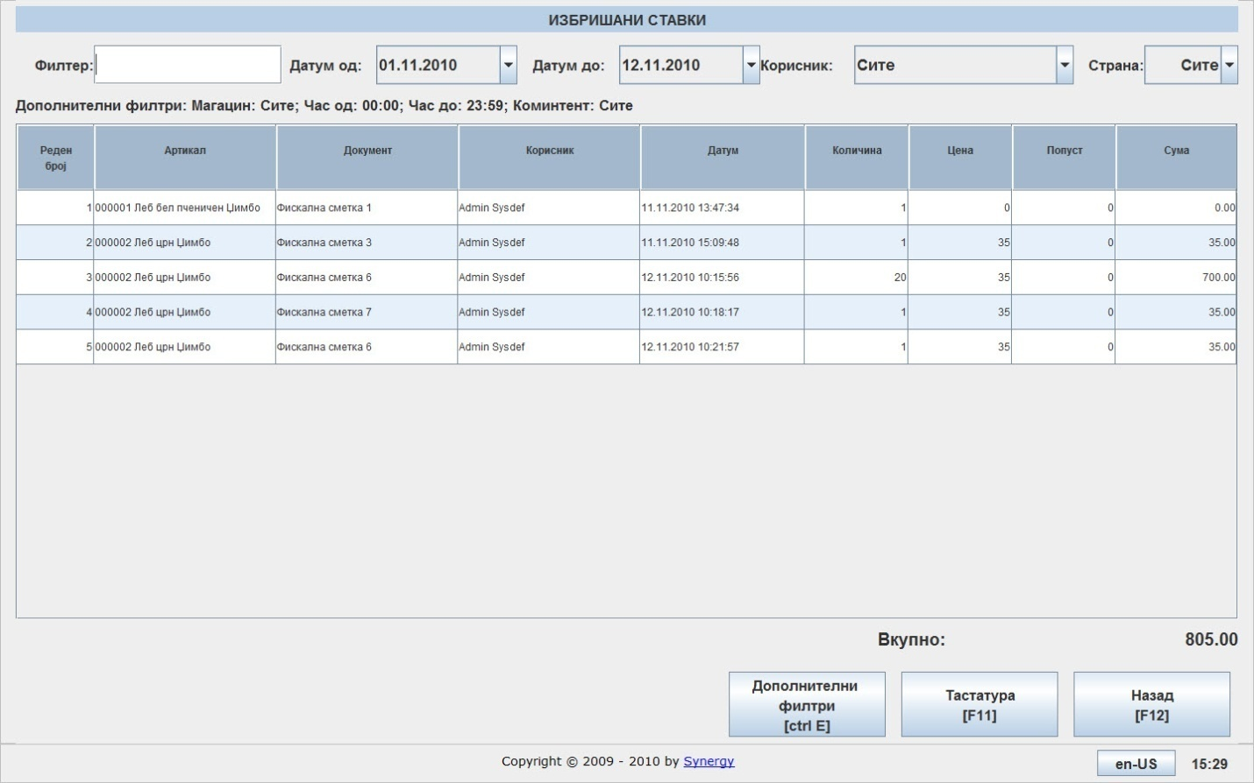

Transaction history of services

This report serves as a journal for sold services. The service should be created in the Item repository as a Service type item.
By pressing 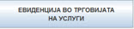 you can get the report in the following format:
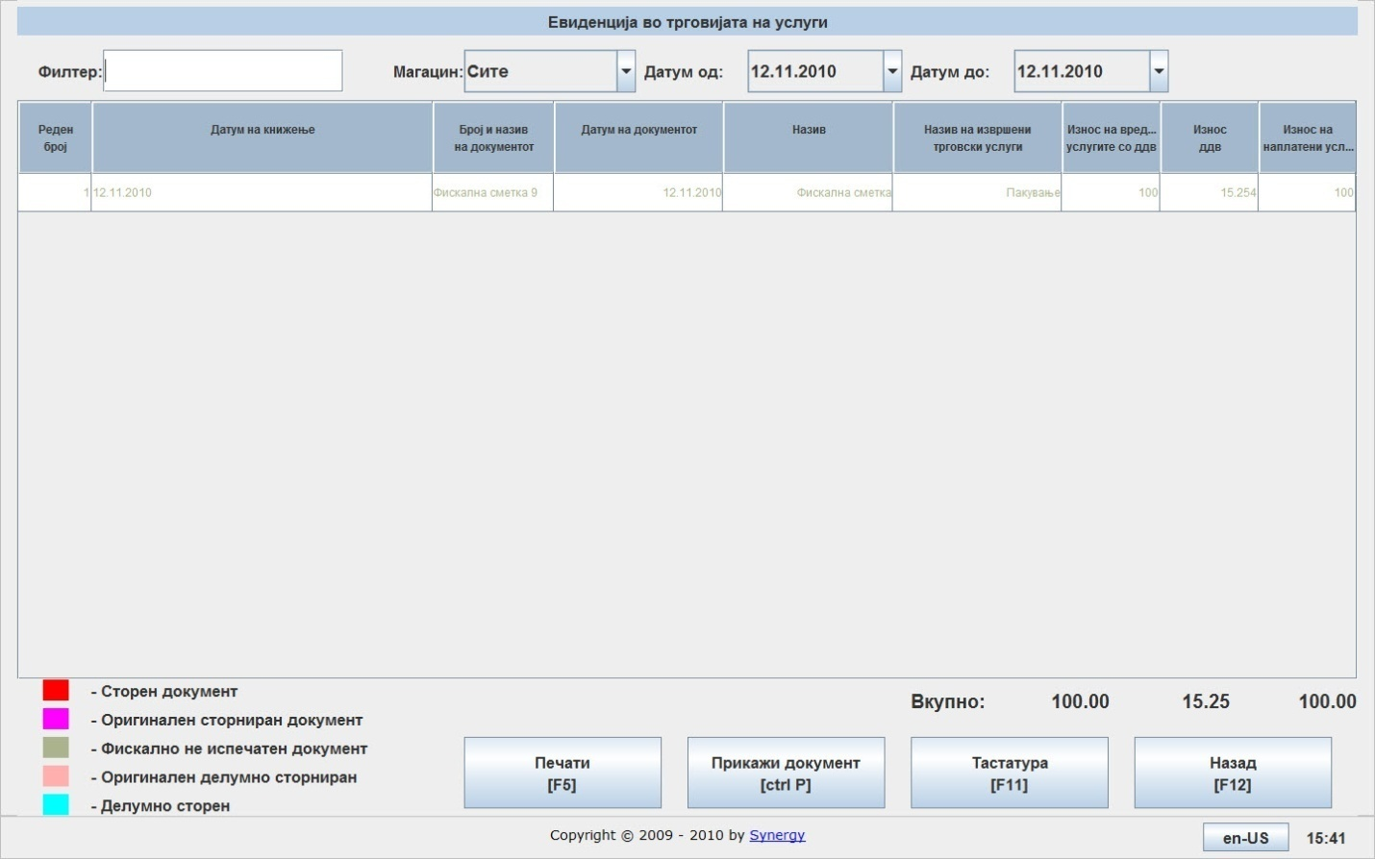
The options to print and preview are available.

Profit margin report

This report is used for obtaining the profit margin for every item.
By pressing 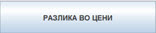 you can use the filters to create the desired report filtered by time interval, warehouse, group of items.

After choosing the needed filters the report is ready as shown below:
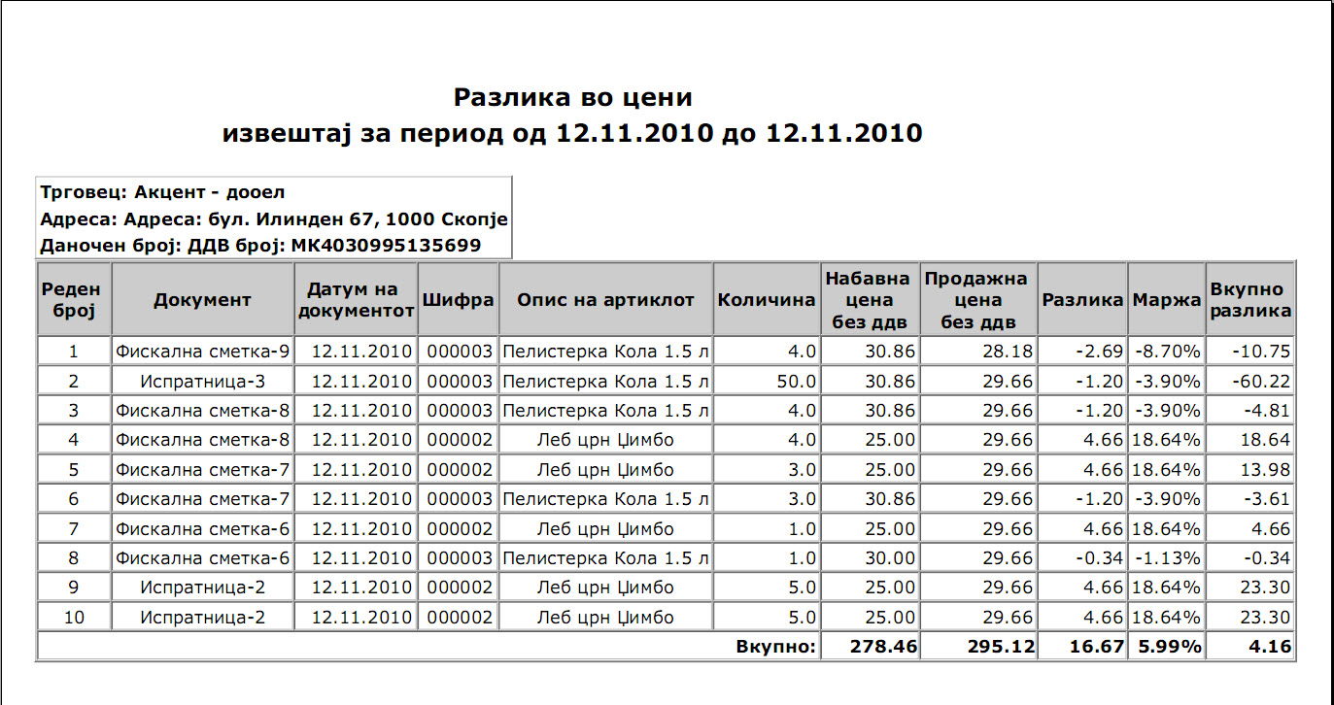

Creating, modifying and printing of documents

You can enter this menu buy pressing 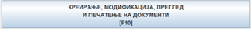 in the main menu.
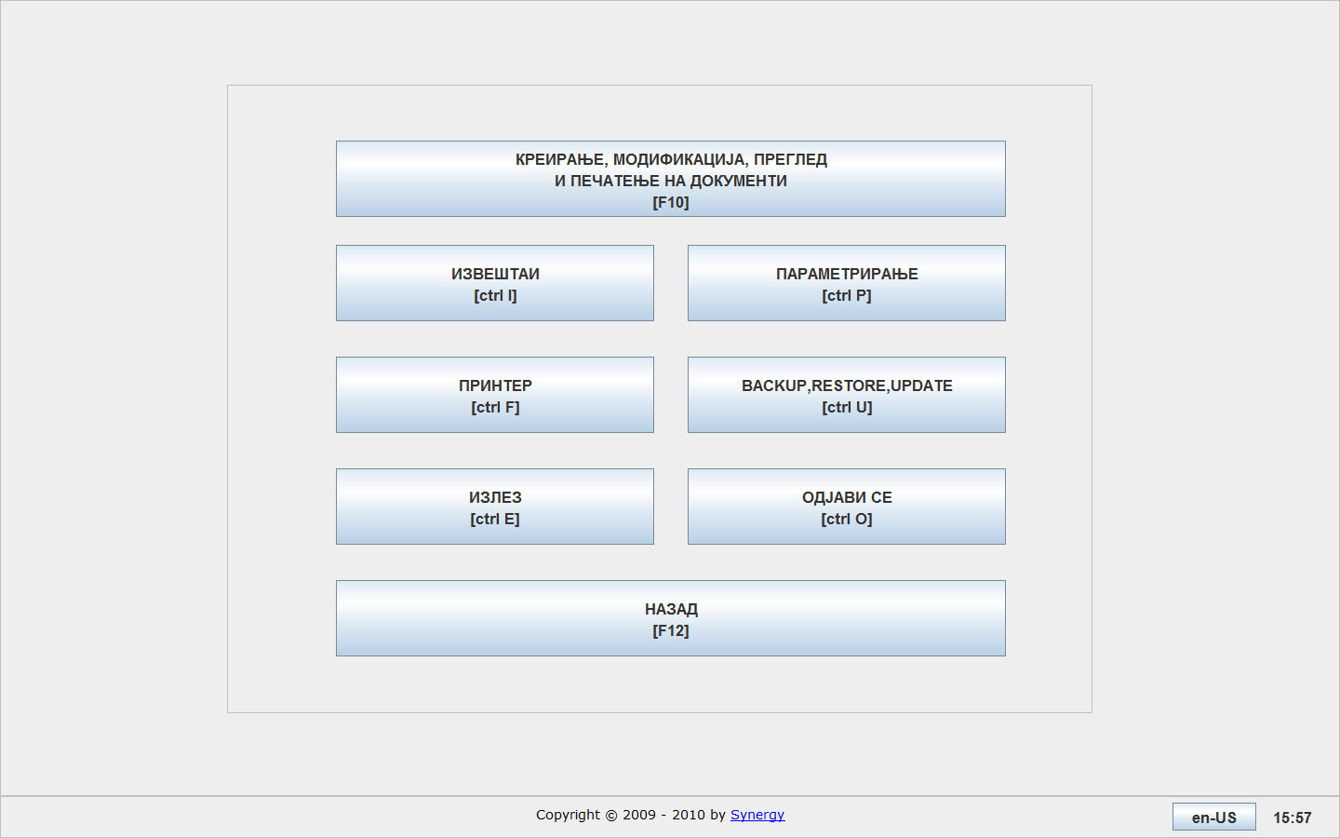
After entering the menu, you get a list of documents which are pre-defined and stabndard with every installation of EasyPOS.

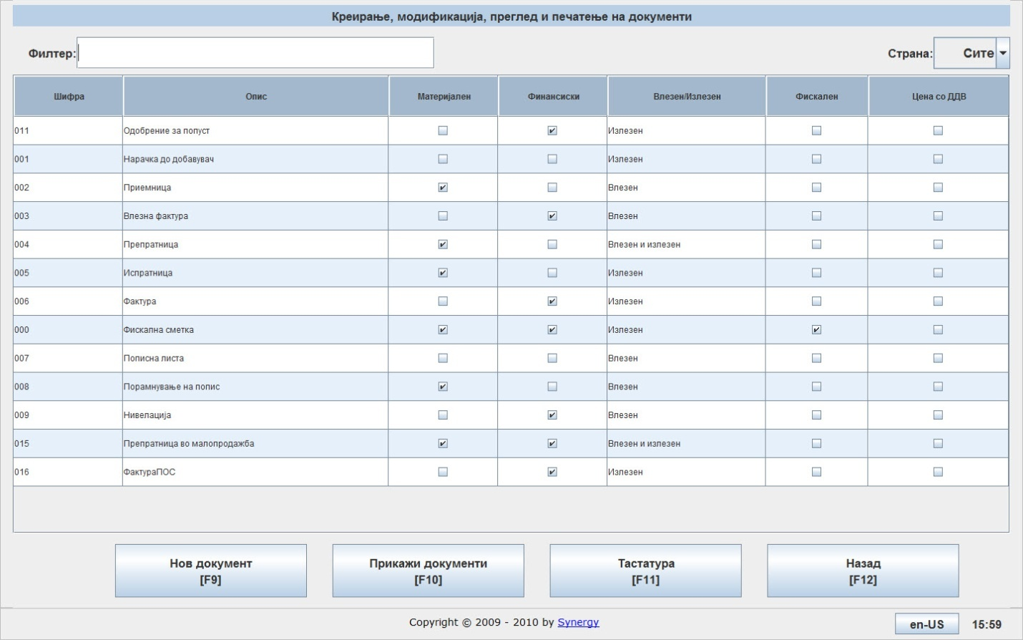
In the column Code shows the code of the document. Description shows the name or type of the document. Material enables or disables the document to make changes in item stock. Financial enables or disables the document to make a payment obligation which places the document or not in the Debts and claims report. Incoming/outgoing shows whether the document causes incoming or outgoing transactions, like procurement or sales. Fiscal shows whether the document should print fiscal receipts or not.
If your company happens to have only one retail warehouse (shop), in that case the option to create new types of documents is disabled due to legal and practical limitations prescribed by law.
In this manual only the following documents will be described in details:
  - Фактура
  - Испратница
  - Препратница во Малопродажба(ПЛТ)

Фактура - Invoice
Can be created in three ways:
- Directly from the main menu by selecting the document type and pressing 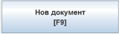
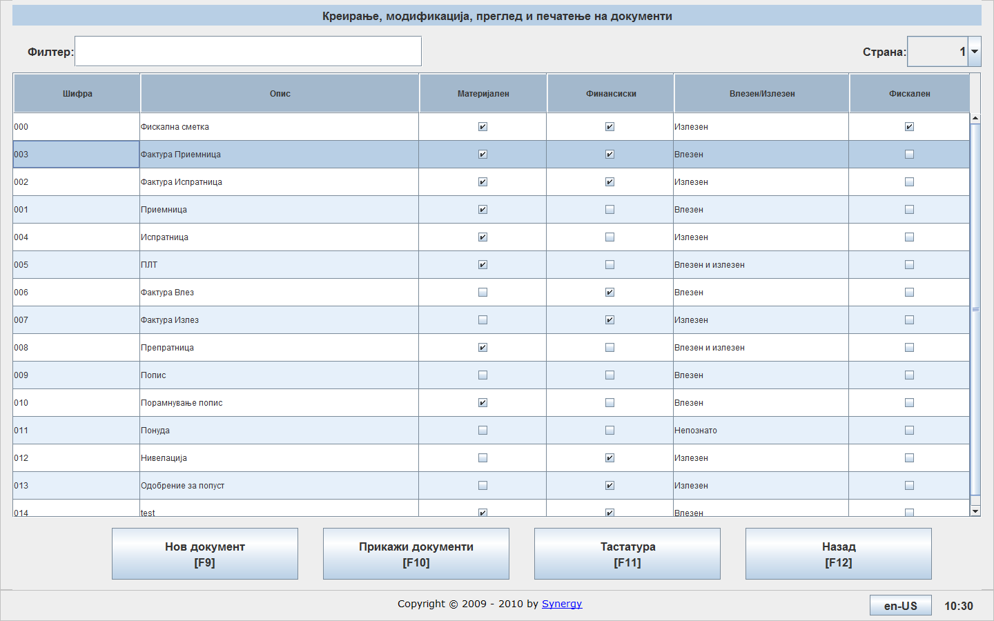

- By double clicking on the document type which leads to entering the menu of that document type and pressing
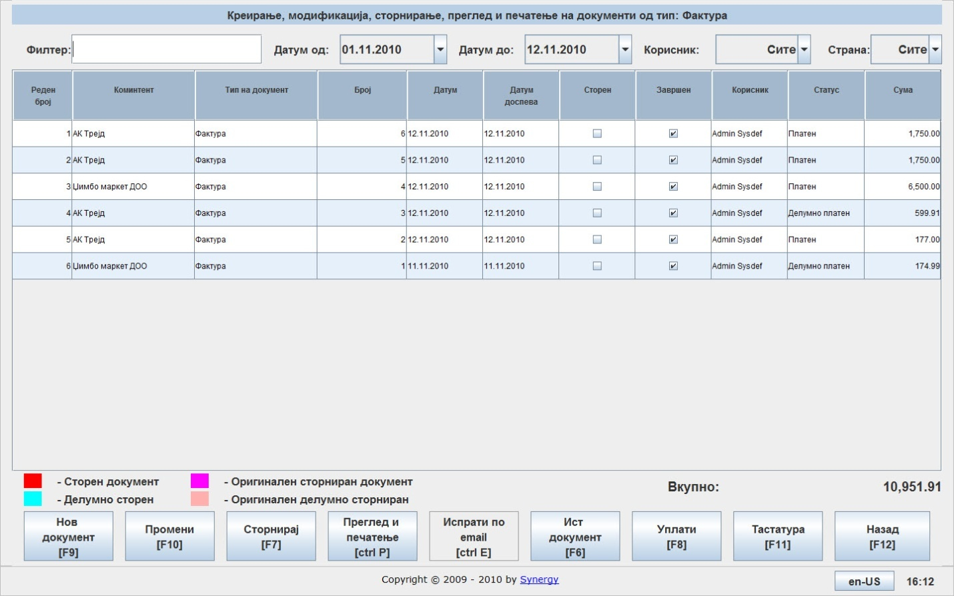
- By double clicking a certain document which enters you to preview the document. You can find the option 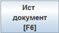 which allows you to create a copy of the chosen document but with different number which saves time and effort in cases where the documents are the same or similar.

When creating an invoice the screen looks like this:
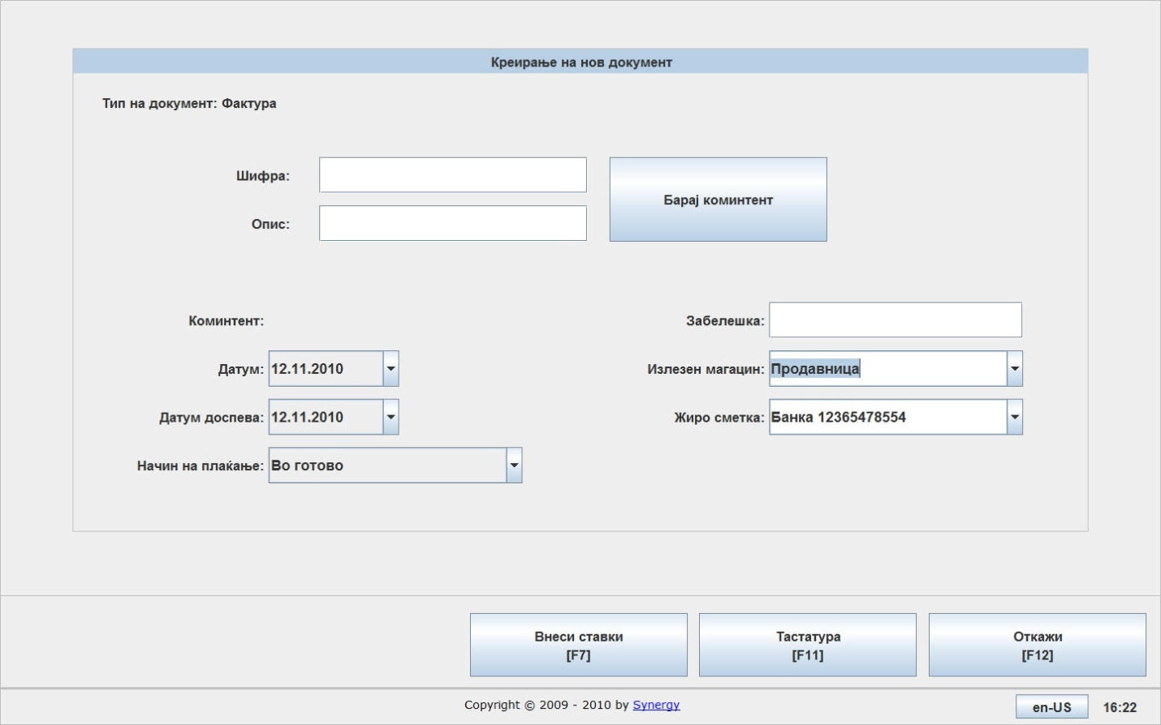
In the field Customer number you can enter the number/code of the customer for which you are creating the invoice. Or you can enter the name of the customer. Either way works with choosing the desired customer. You can also search for the customer from a list by clicking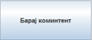.
In the field Date of document the document date is entered and in Due date you can enter the date by which the invoice should be paid.
In the field Method of payment you can choose the way the invoice should be paid.
In the field Note you can add any text you feel needed.
In the field Output warehouse you can enter from which warehouse the items are shipped.
After you fill the fields above you can start adding the items by clicking 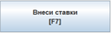.
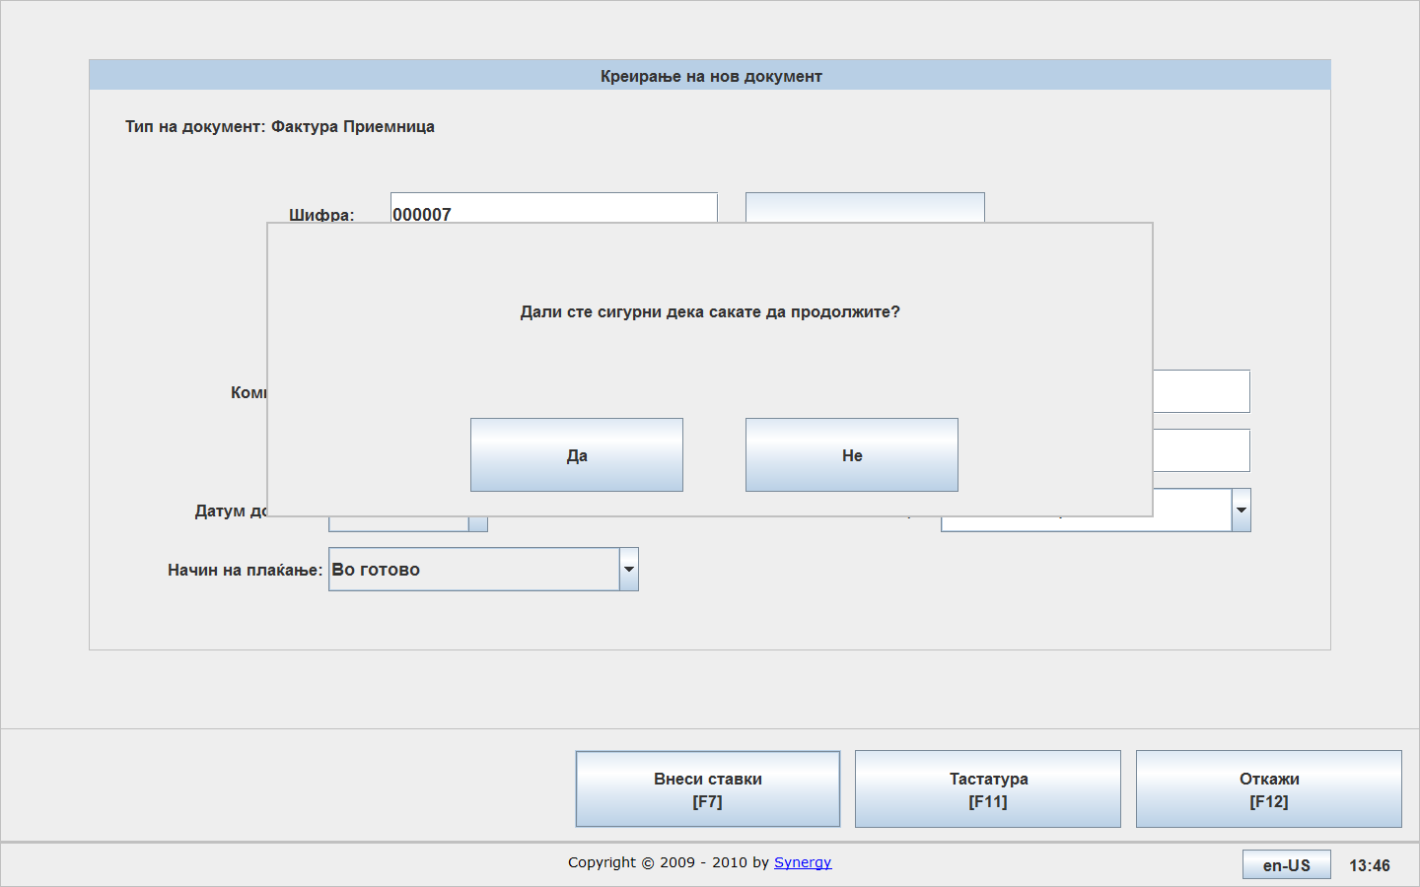
After confirming the screen for entering items will appear.
If you know the item code or description you can enter and choose it directly. If not, you can search for the item from the list by clicking Search.
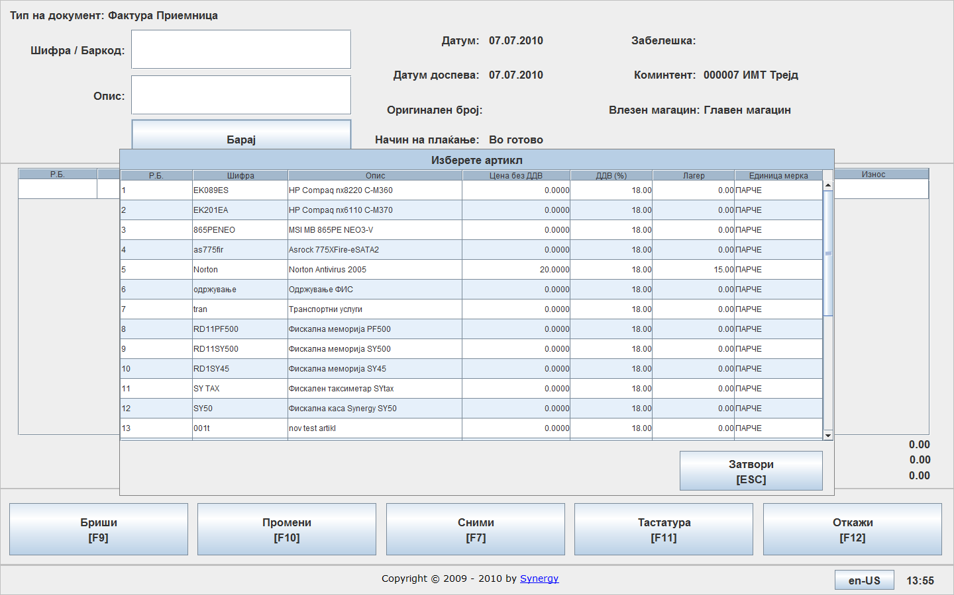
The item quantity and price without VAT is entered in the corresponding fields.
The standard buttons are offered on this screen:
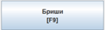 Press for deleting an item од документот
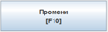 Press for changing an item
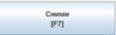 Press for saving the document
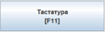 Press for on-screen keyboard
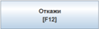 Press for canceling the invoice

In the main menu the following options are available:
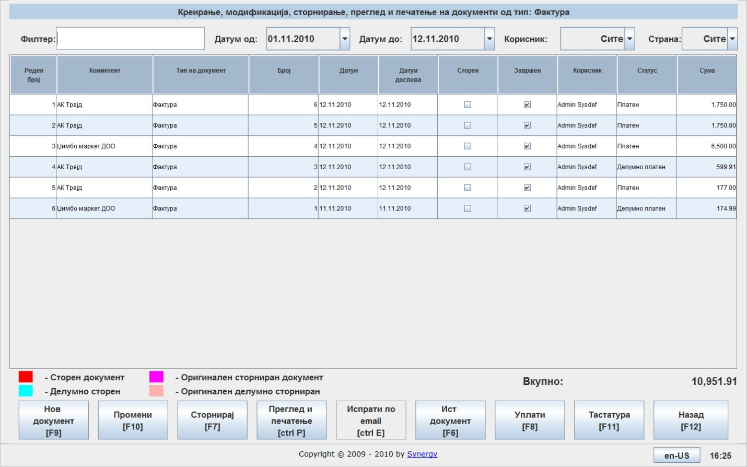
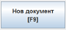 Press for creating a new document
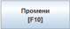 Press for editing a document. First select the document from the list and then press the button
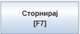 Press for cancelation of an existing document. First select the document from the list and then press the button
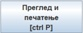 Press for preview and print of selected document. It can be printed in normal mode and PLT mode.
Press to create a document which contains the selected document’s data
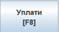 Press to enter a received payment from an invoice
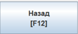 Standard button for going back to previous window

Испратница
Can be created in two ways:
  - Directly from the main menu by selecting the type of document and pressing
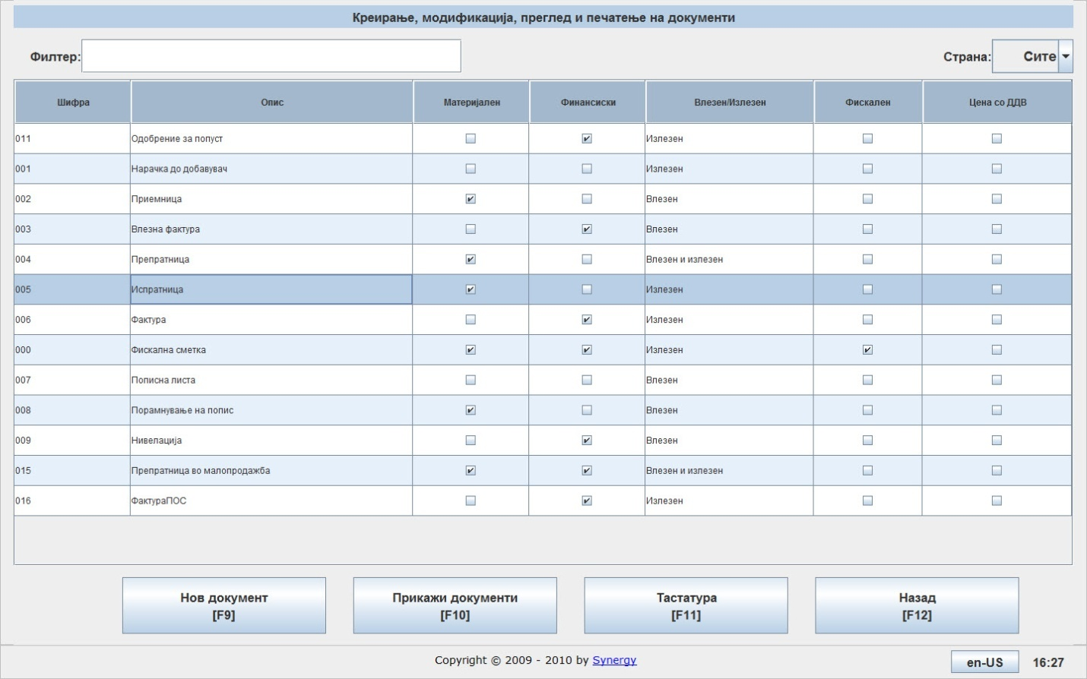
  - By double clicking on the document type, which enters the menu of the document type and by pressing

Regardless of the way you have chosen to access the document, you receive the same screen as shown below:
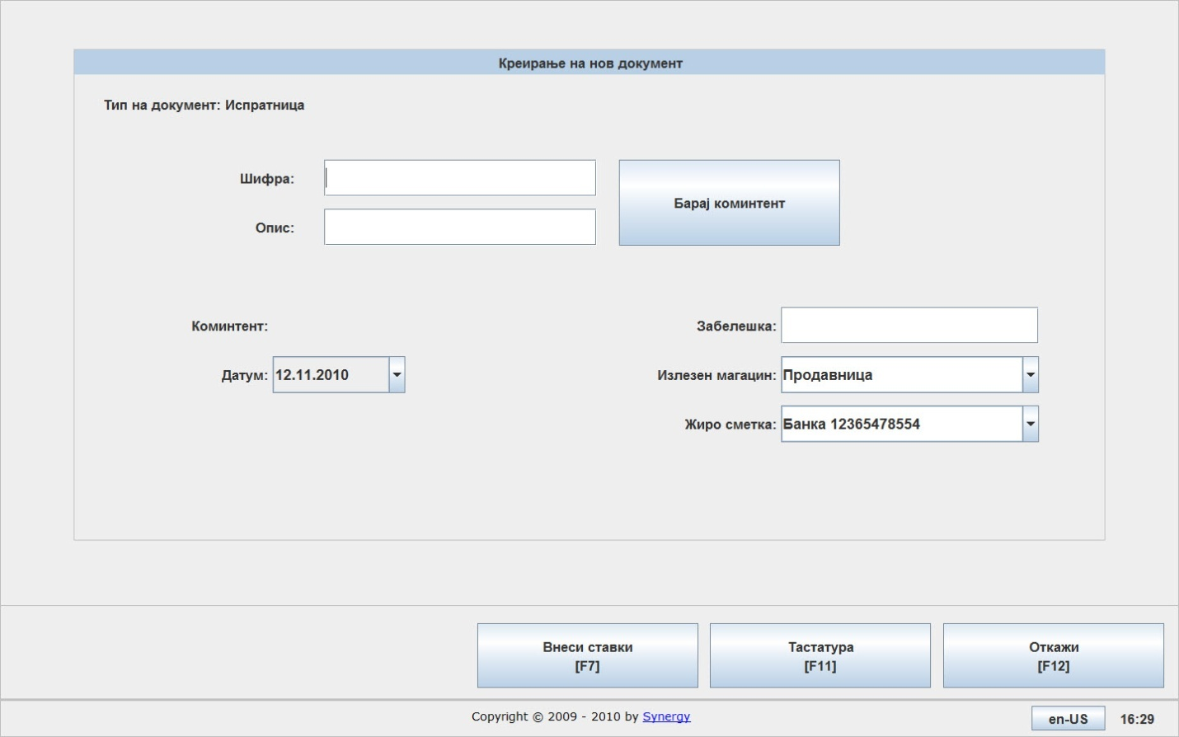
You can enter the customer by writing the code or name. You can also click and select it from a list.
In the field Date you can set the date of the document.
In the field Note you can add any text you need.
In the field Warehouse you can choose the warehouse from which the stock exits.
You can start entering the items by clicking.

Confirmation dialog appears.
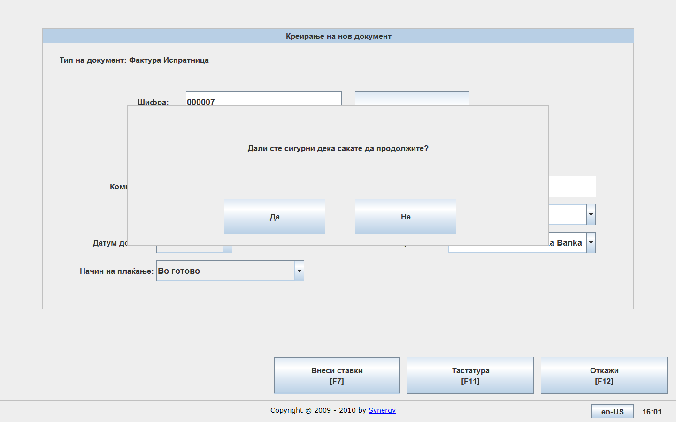
After confirming you can start entering the items.
If you know the exact item code or description you can enter it directly. If not you can search the item from a list.
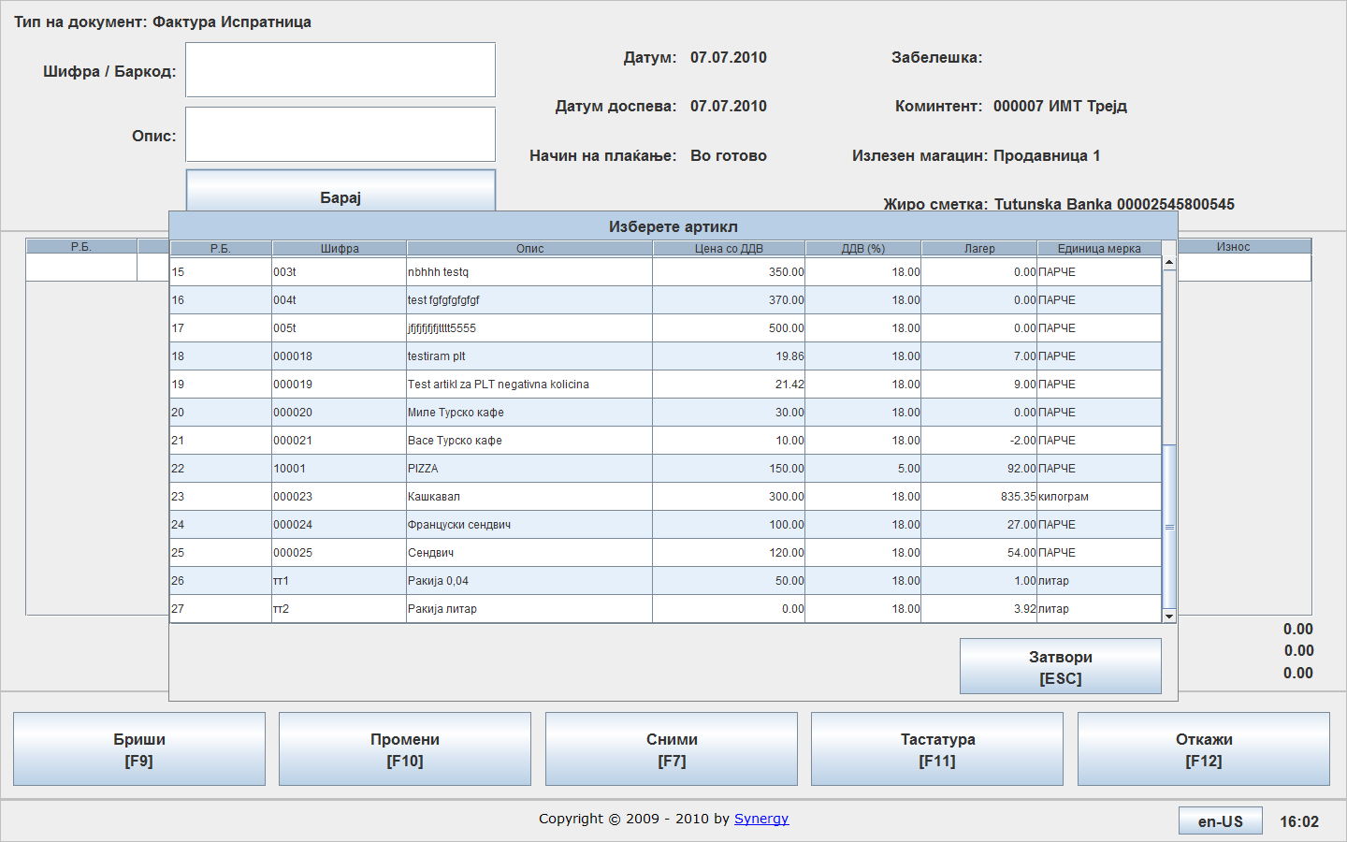
You need to enter the item quantity and the price is taken from the pricelist which will be covered later in this manual. Also here you can enter an amount for discount.
The standard buttons are offered on this screen:
Press for deleting an item од документот
Press for changing an item
Press for saving the document
Press for on-screen keyboard
Press for canceling the invoice

In the main menu for the selected document type you have the following options:
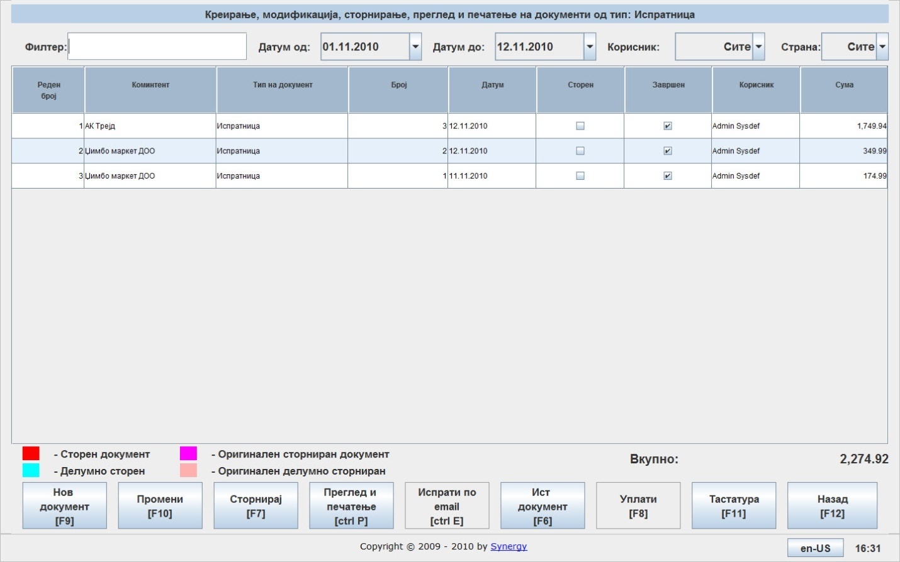
Press to create a new document
Press to edit an existing document by selecting the document first.
Press to cancel an existing document by selecting it first.
Press to preview and print a selected document.
Press to create a document with the same contents as the selected document.
Press to go back to previous screen.

Transfer from warehouse to retail store (PLT)
This document is available if you have a single or more warehouses and a retail store and you need to transfer stock from the warehouse to the store.
Can be created in two ways:
  - Directly from the main menu by selecting the document type and pressing
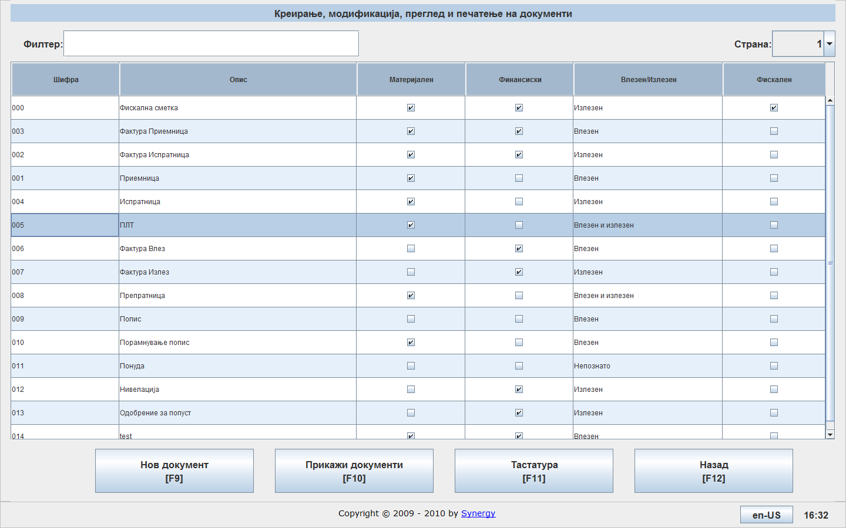

  - By double clicking on the document type and pressing
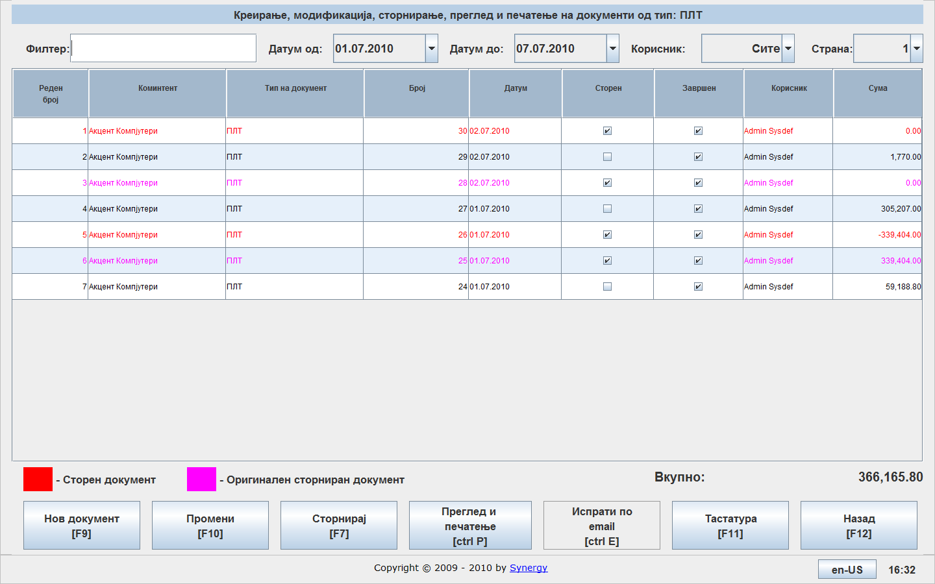
The screen looks like this:
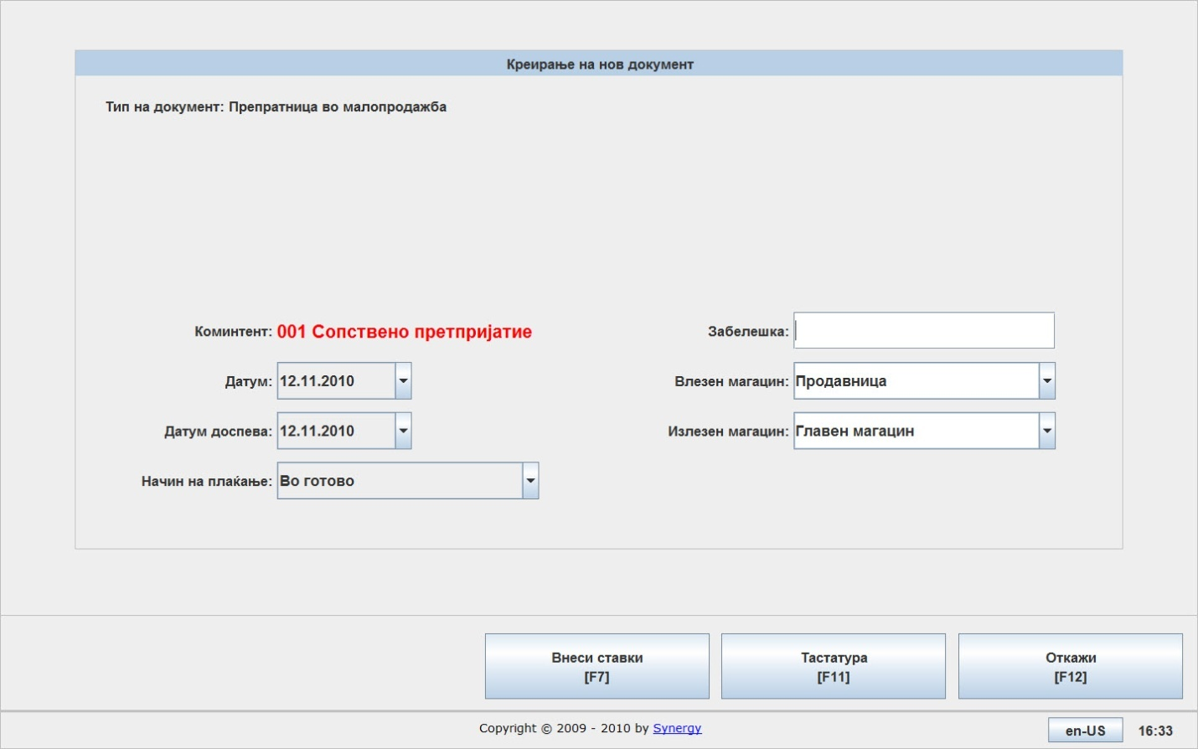
In the fields Input warehouse and Output warehouse can be chosen the input and output warehouses.
After needed fields are filled, press to start entering document items.
You get the following screen to confirm.
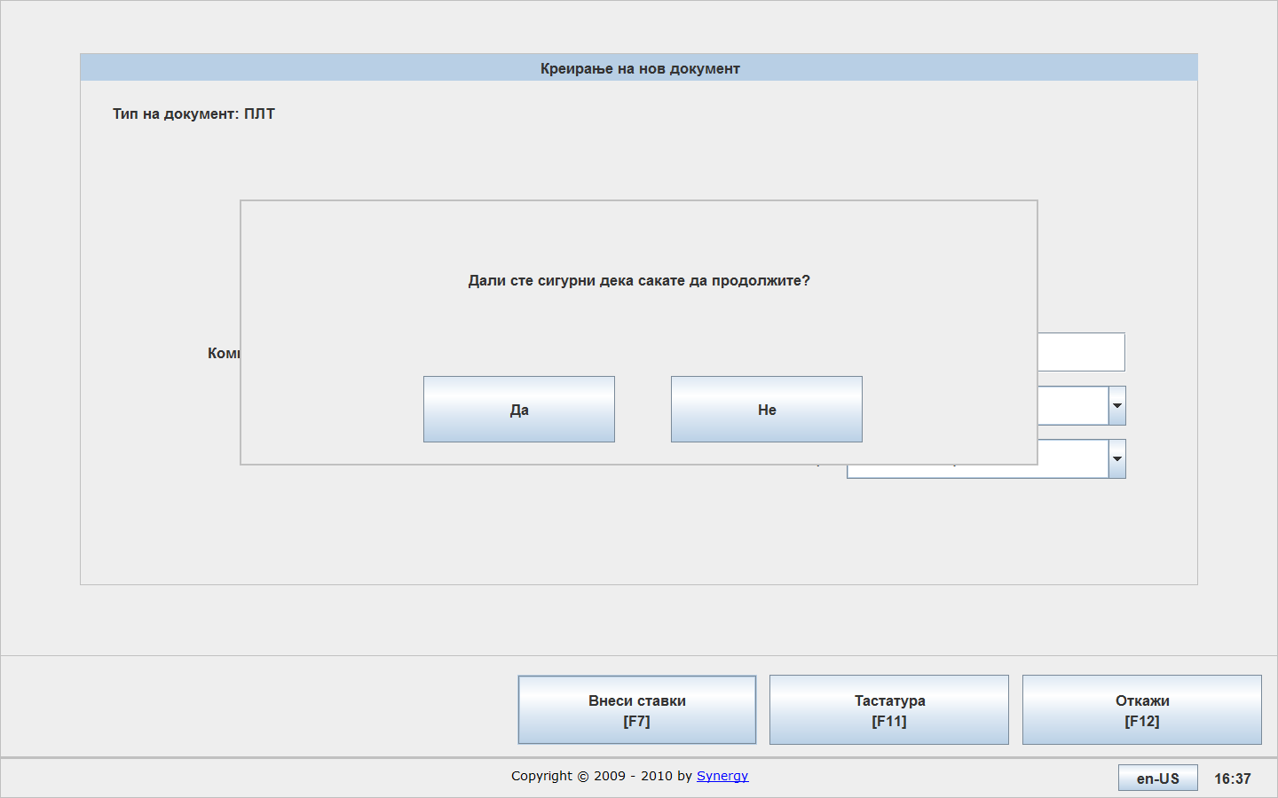
After confirming you can start entering items.
If you know the exact item code or description you can enter it directly. If not you can search the item from a list.

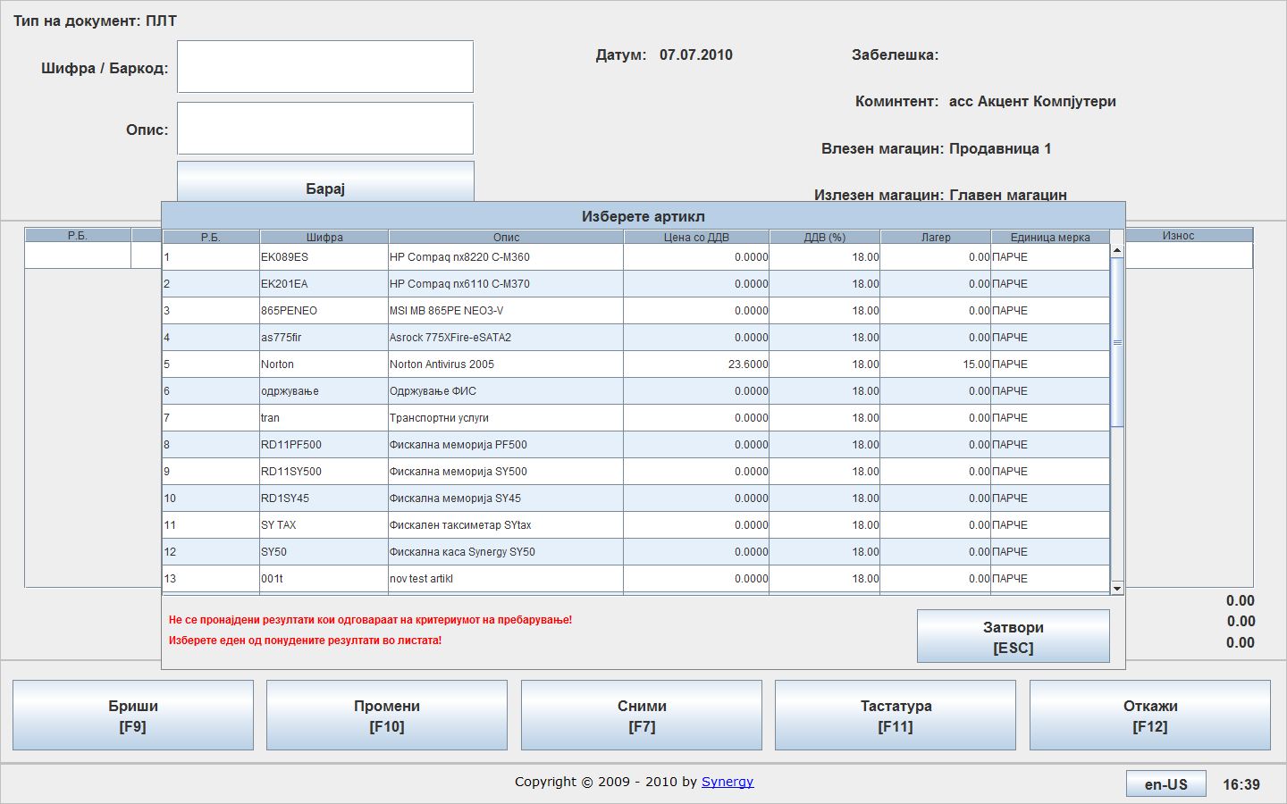
Enter an amount only.
The standard keys are available:
Press to delete a selected item from the document,
Press to edit a selected item from the document,
Press to save changes to the document,
Press to display the on-screen keyboard,
Press to cancel the document changes.

In the main menu of the document type, the following options are available:
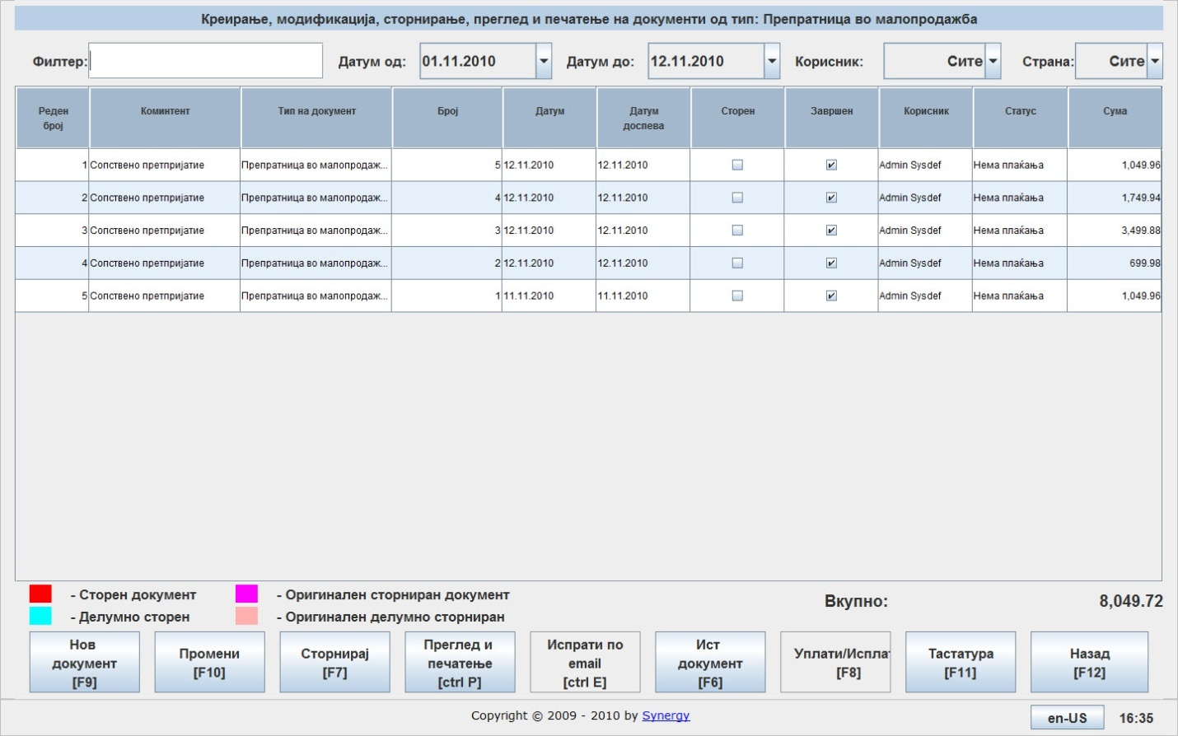
Press to create new document of the selected type,
Select the document and Press to change document properties,
Select the document and press to cancel it,
Press to preview or print a selected document,
Press to create a document of the same type,
Press to go back to previous screen,

Parameterization
easyPOS allows parameterization of the system, the accessing is via main menu and pressing the button 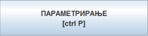.
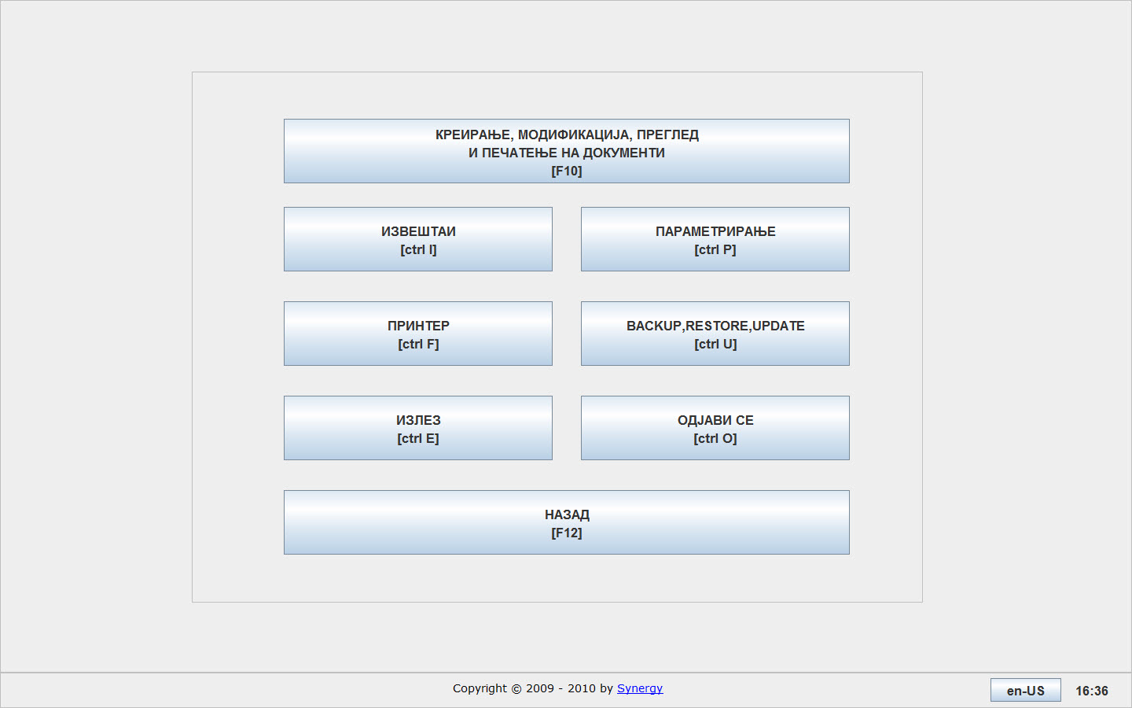

After selecting the option parameterization it will appears following screen:
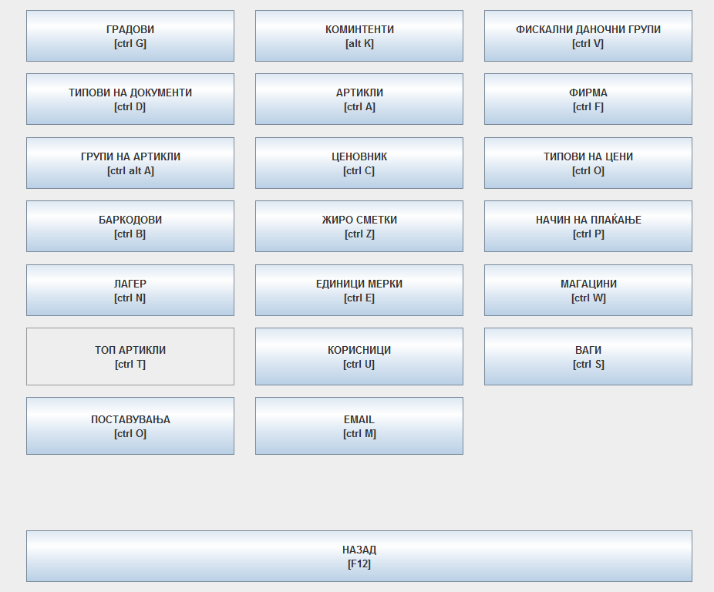
In the field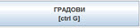 you can enter cities.
In the field you can define types of document that will be including in the system.
In the field you can define groups of items that will be exist in the system.
In the field you can enter the bar-codes articles.
In the field you can define if the system can allows negative stock and alarm quantity.
In the field 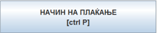 you can define ways of payment which will be available in the system.
In the field you can enter new clients, modify or delete existing clients
In the field you can enter new items, modification and deletion of existing ones. The system allows working with complex items (составници).
In the field you can enter price list for articles.
In the field you can enter bank accounts of the company.
In the field you can enter units’ measures, related items that you sell.
In the field 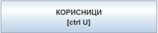 you can enter new users, as well as modification and deletion of data for existing users.
In the field 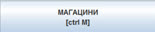 you can enter new warehouses, as well as modification and deletion of existing, if it has not previously created documents.
In the field you can enter data for company.
In the field you can enter additional types of prices, if is necessary.

Document types
Once you have selected the option for creating types of documents, will appear next screen, where you have the following options:
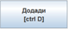 is serves to adding new types of documents,
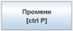 is serves to changing the exist types of documents,
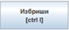 is serves to deleting the exist types of documents,
Note: You cannot make any changes or deletion of documents if there are defined as systematic. 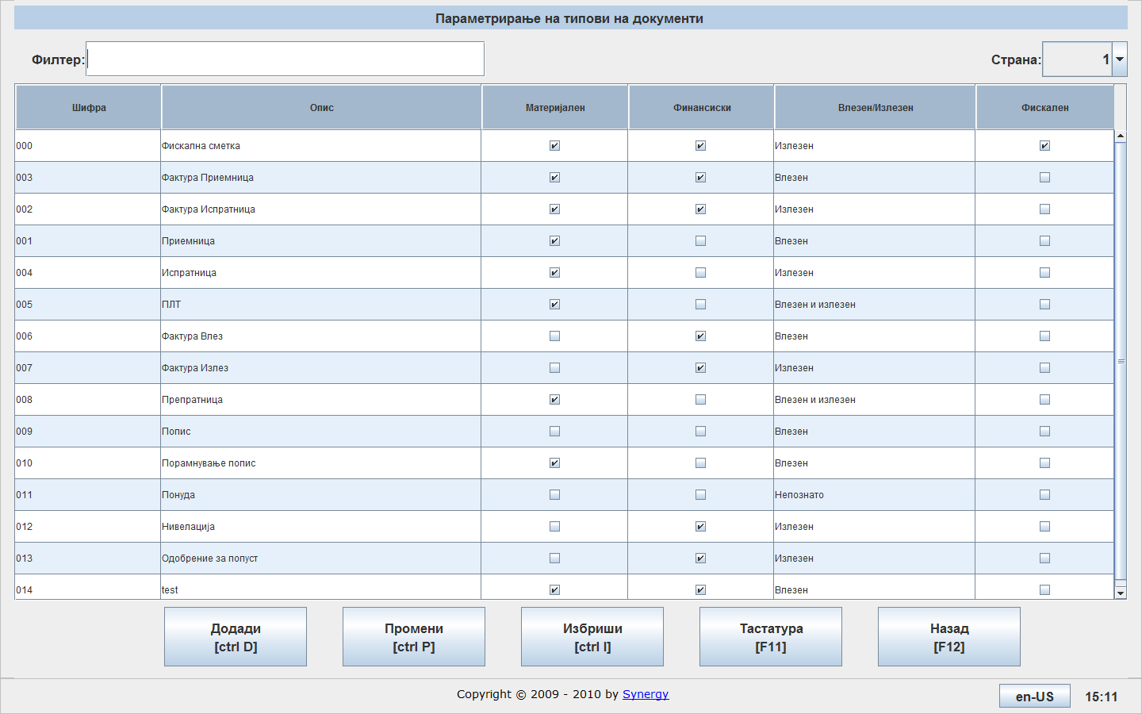

To create a new type of document, press the button, than will appear following screen.
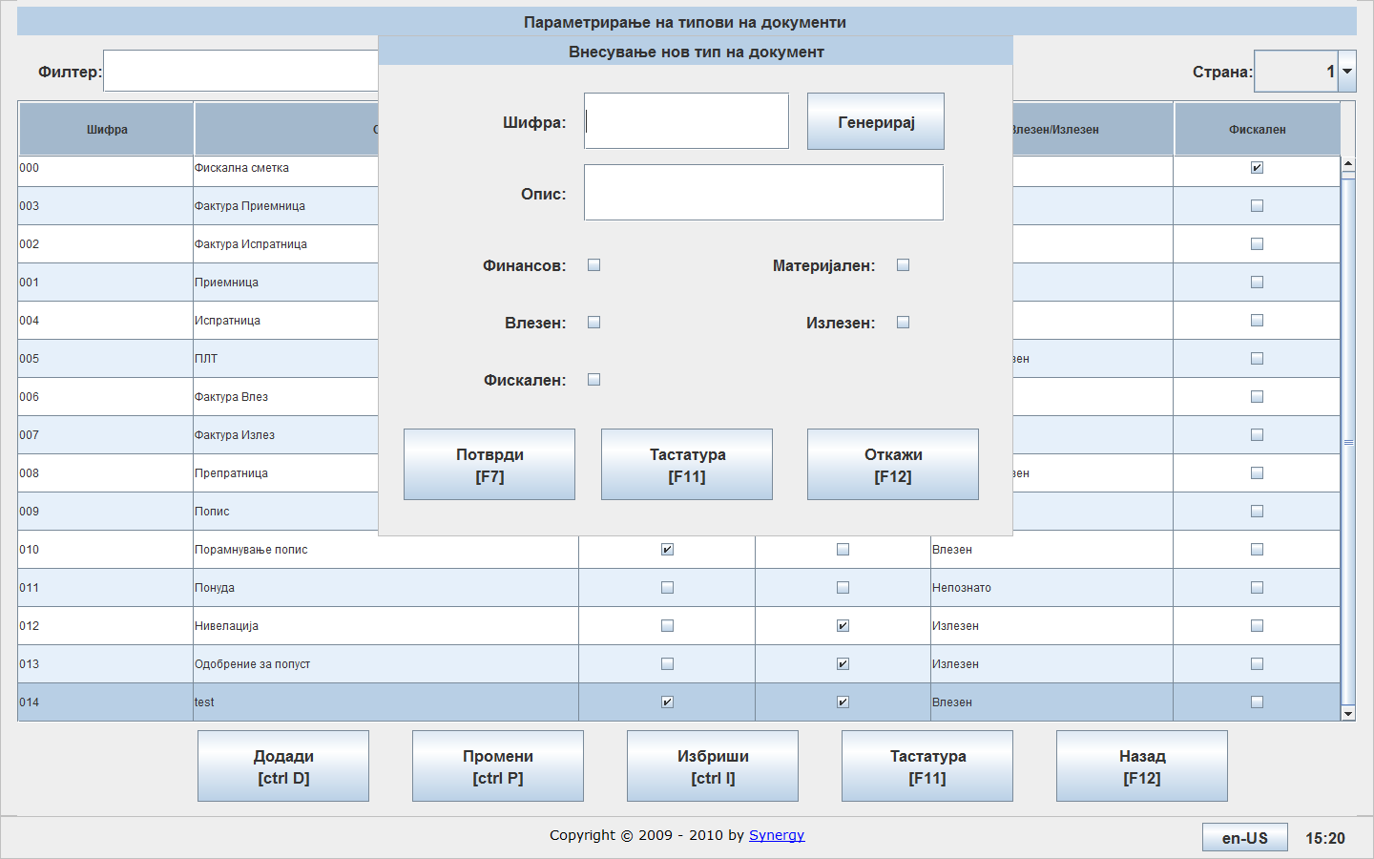
In the field “Code” you can enter number that you will define, or you can allow the system automatically generates by pressing the button “Generate” .
In the field “Description” you can enter description of the type of document, see example image below:
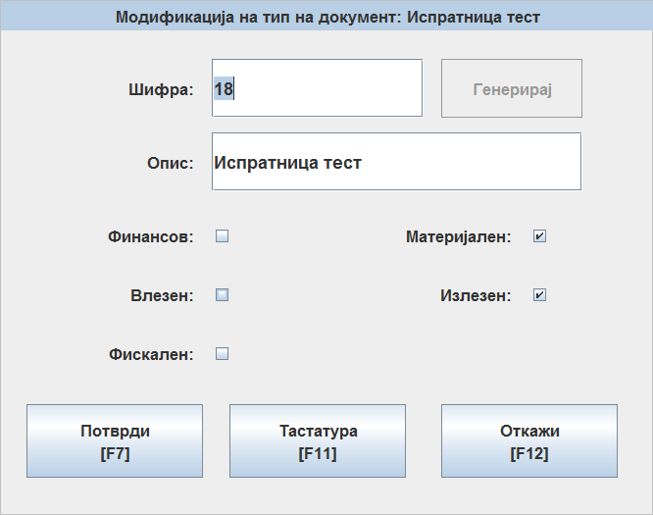
Depending on the type of document, you can chose it is Финансов, Влезен, Фискален, Материјален, или Излезен документ.
In the example shown above, it is created a type of document which is испратница којашто е материјален документ, и излезен документ. When creating a document with this type of document system will perform decrease the inventory of the terms, but there will not be financial implication.
By pressing 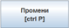, you can change the types of documents that you have created.
By pressing 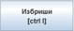, you can perform deletion of the types of documents that you have created.

Group items
By pressing the button will open the following screen, where you have the default options: Add, Change and Delete.
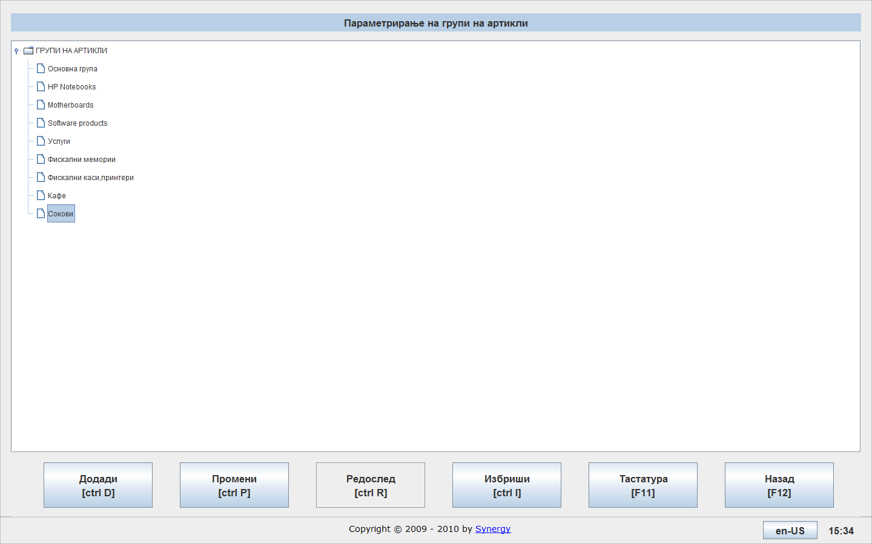
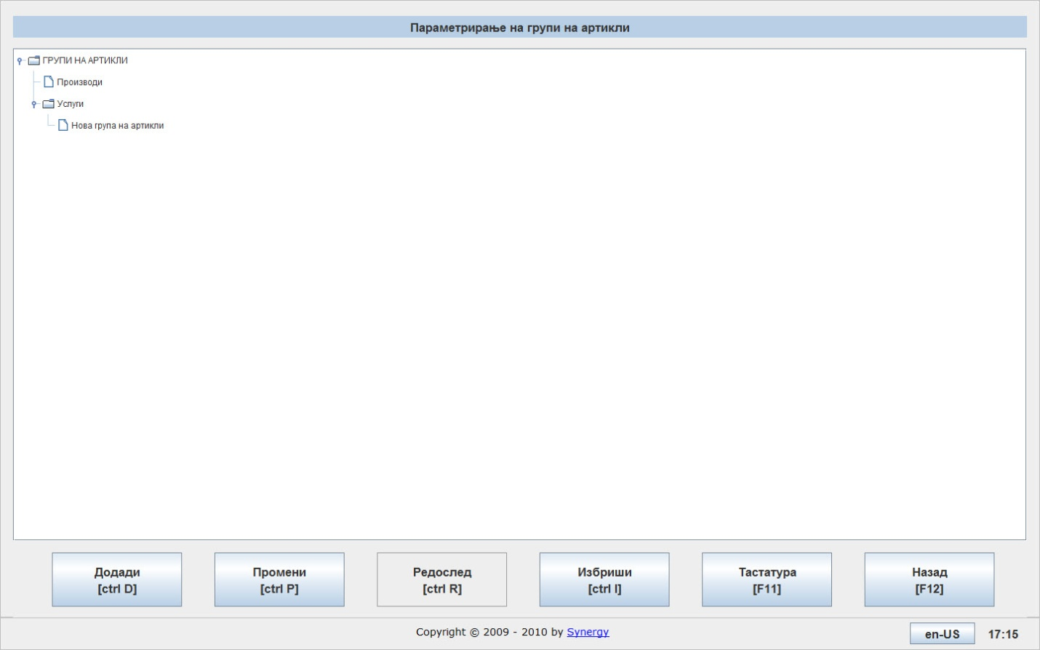
If you want to create a sub-group of a group, than you can select the group for which you want to create a sub-group and press the button “Add” and enter the name of the sub-group or group that you want to create.
If you want to change a group, select the group and press.
If you want to delete a group, select the group and press.

If you insert some items in the group “Service”, than those items cannot be selected when you create материјален документ на пр. Приемница, испратница, препратница итн.

Bar-codes
By pressing the button will open the following screen, where you have default options: Add Change and Delete.
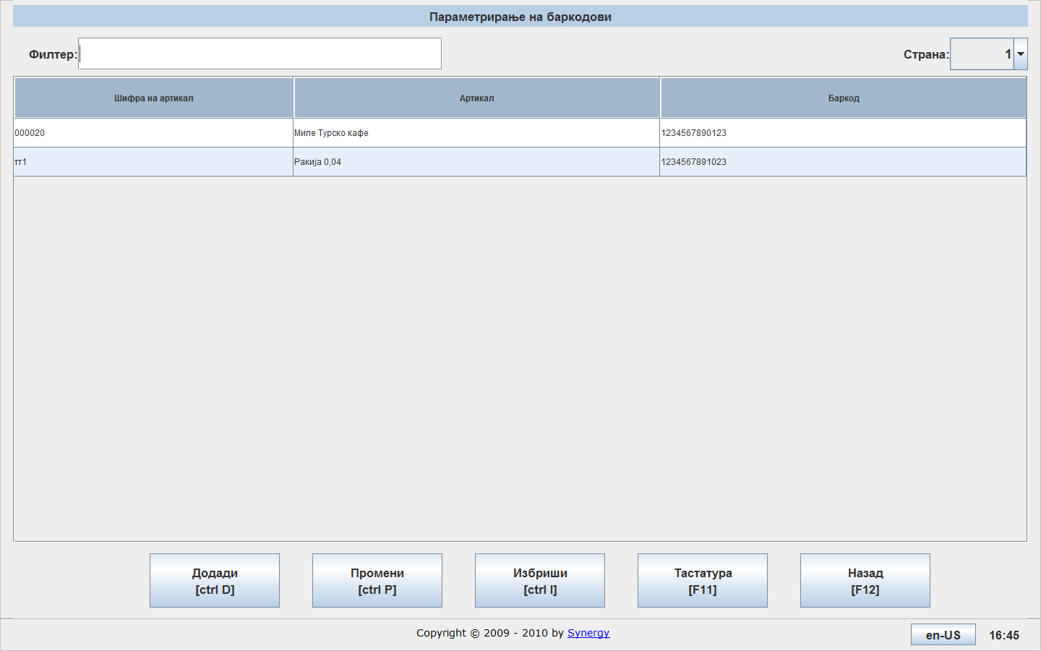

By pressing the button 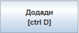 will open the following screen:
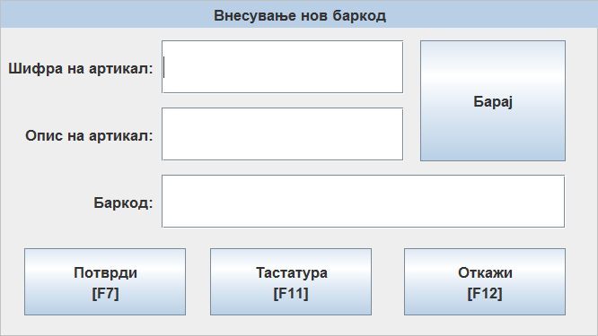
In the field “Item Code” enter the code of the item, if you do not know the code, press the “Search” button to find appropriate item code.
In the field “Bar code”, enter the bar code of the item.
Note: System does not allow input the same bar code for two different items.
If you want to change some bar code, select it and press the button.
If you want to delete some bar code, select it and press the button.

Stock
If you want the system to support negative stock, press the button, will open the following dialog:
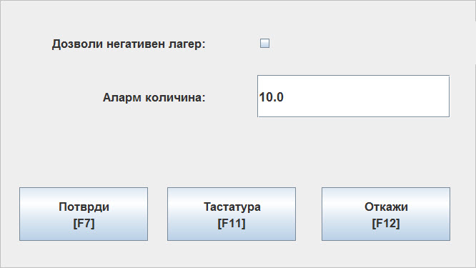
If you want a negative stock, than you can select the check box: “Allow negative stock” and press the confirm button.
In the field “Alarm quantity” Аларм количина, enter the amount, if the stock reaches this amount, the system will notify you.

Payment method

By pressing the button it will open the following screen, where you have the default options: Add, Change and Delete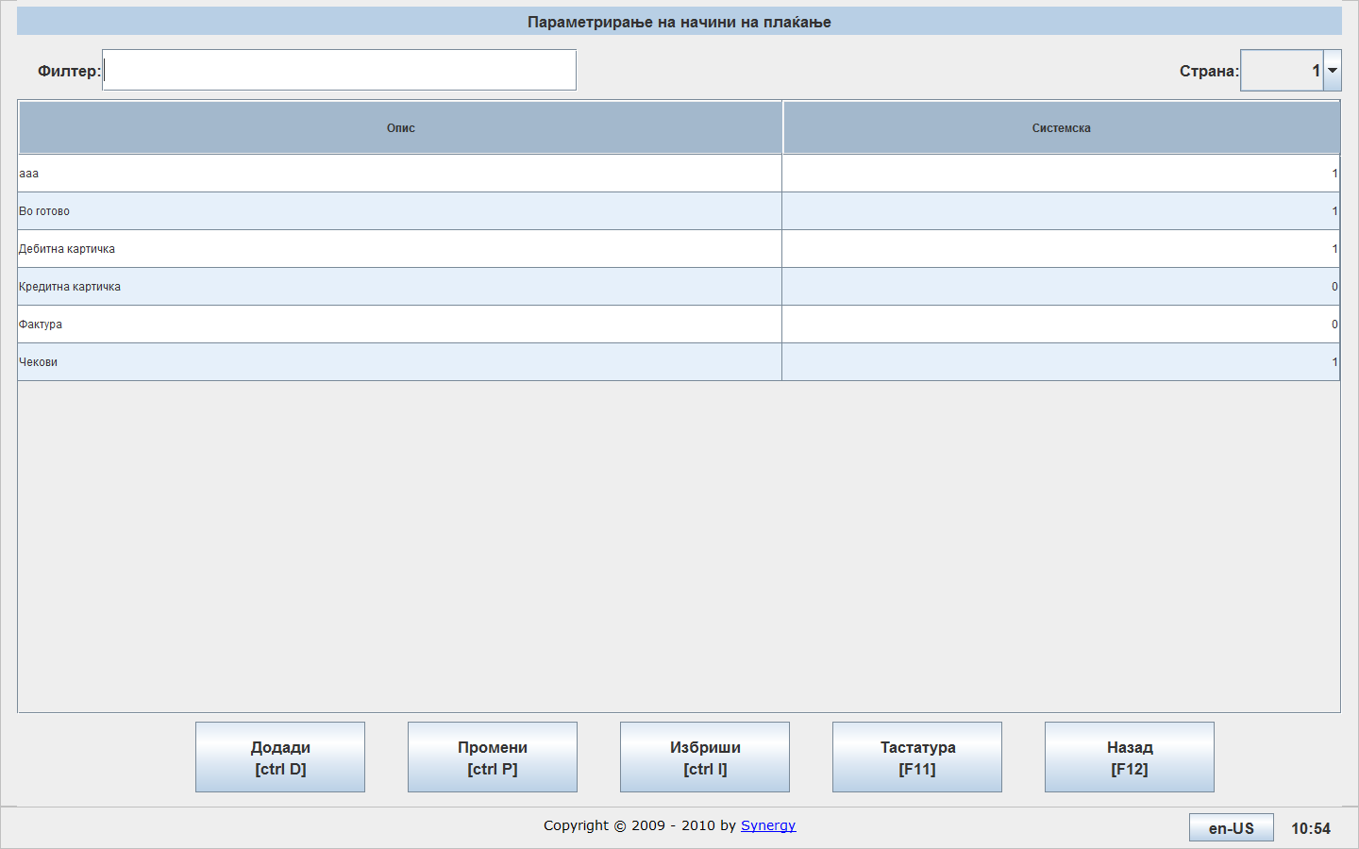

By pressing the button it will open the following screen:
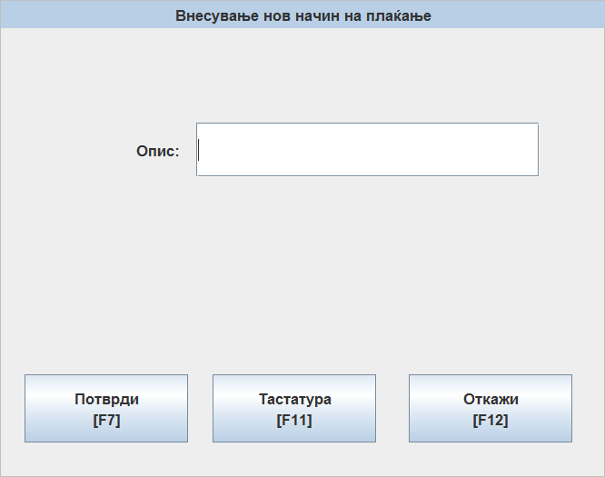
In the field “Description”, you can enter the description of the method of payment.
And by pressing the button indicate your data entry.
If you want to change your payment method, select it and press the button.
If you want to delete a payment method, select it and press the button.

Clients

By pressing the button it will open the following screen, where you have the default options: Add Change and Delete. 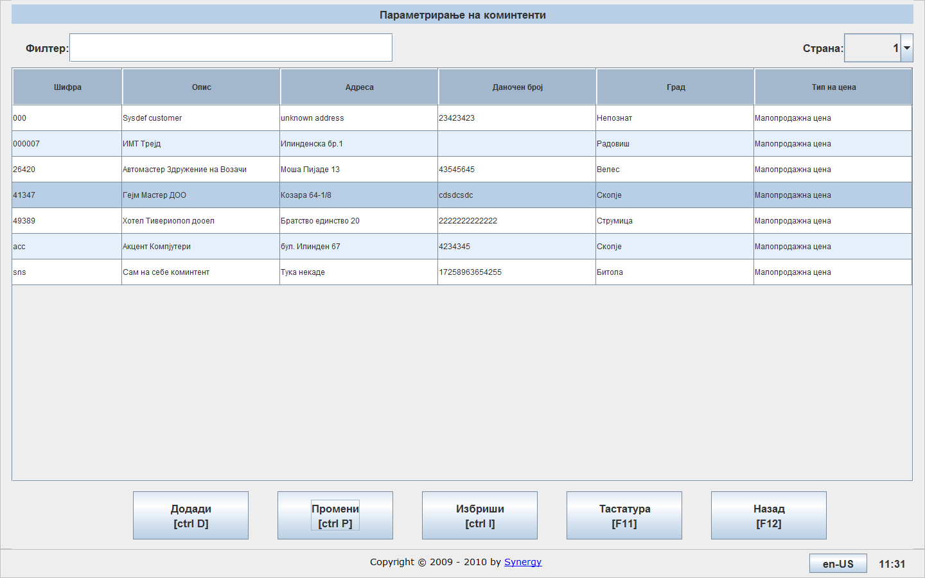

By pressing the button it will open the following screen:

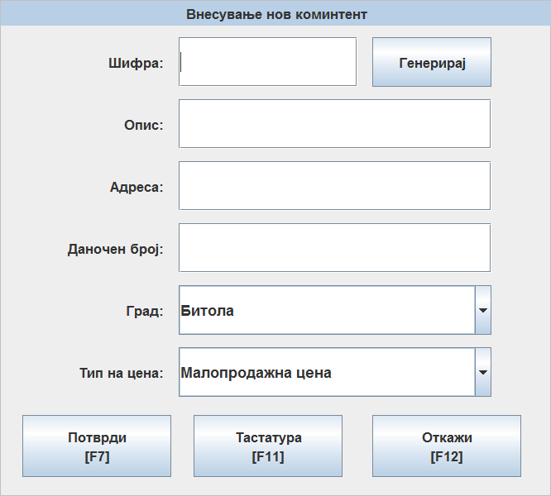
In the field “Code”, you can enter client code by your choice, or if you want the system itself to generates a code, than press the button.
In the field “Description”, you can enter the name of company/person to your clients.
In the field “Address” you can enter the address of the client.
In the field “Tax number” you can enter the tax number of the client.
In the field “City” you can enter the city of the client.
In the field “Price type” you can enter price type that will apply for that client.
If you want to change a client, select it and press the button.
If you want to delete a client, select it and press the button.

Items

By pressing the button you can open the fallowing screen, where by the default options: Add, Change and Delete, there are complex item, Print all pages and Print current page.
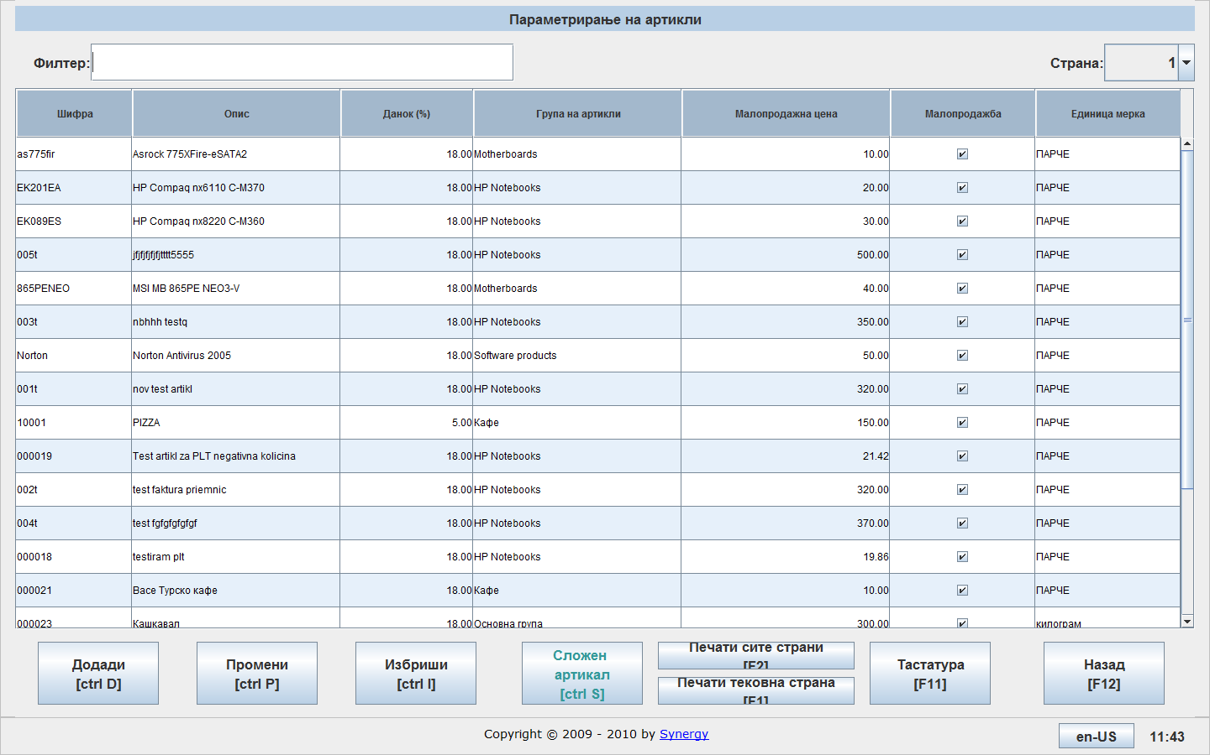

By pressing the button it will open following screen:

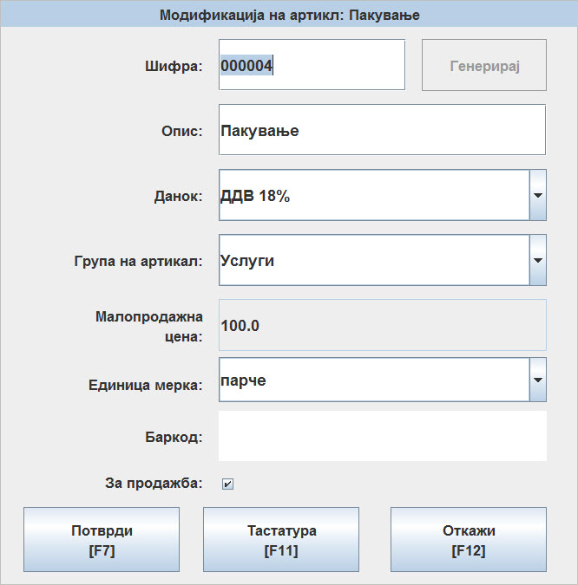
In the field “Code”, you can enter item by your chose, or if you want the system to generates code than press .
In the field “Description”, you can enter description of the item.
In the field “Tax”, you can enter the type of tax that applies to this type of item, according to legal regulations.
Во полето Данок, го внесувате типот на данок којшто важи за овој тип на артикл, согласно позитивните законски прописи.
In the field “Item group”, you can enter group of item to witch this item belongs.
Во полето Група на артикал, ја внесувате групата на артикал на којашто припаѓа овој артикл.
In the field “Retail price” you can enter price for this item
Note:
Во полето Малопродажна цена внесувата малопродажна цена за овој артикл, * забелешка: Доколку внесете малопродажна цена во шифрата на артиклот истата не може да се менува во ценовникот со артикли.
In the field “Unit of measure” Единица мерка, you can enter
ја внесувате единицата мерка за овој артикл.
In the field “Barcode”, you can enter barcode for the item with barcode reader.
With selecting “Retail price”, you choose that this item is for retail price.
With pressing the button “Confirm”, you can confirm your data for entering.
If you want to create complex item (recipe), this is the procedure:
First you will create item like simple item.
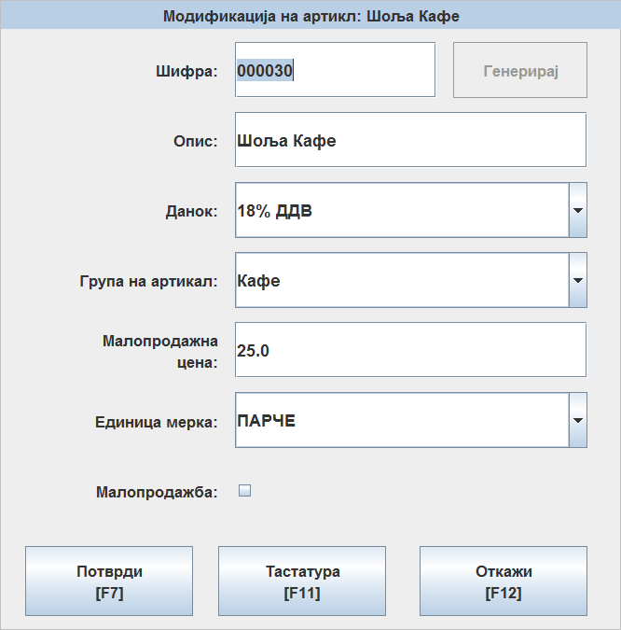

Than you will select the item which you want to be complex, and press the button Complex item.
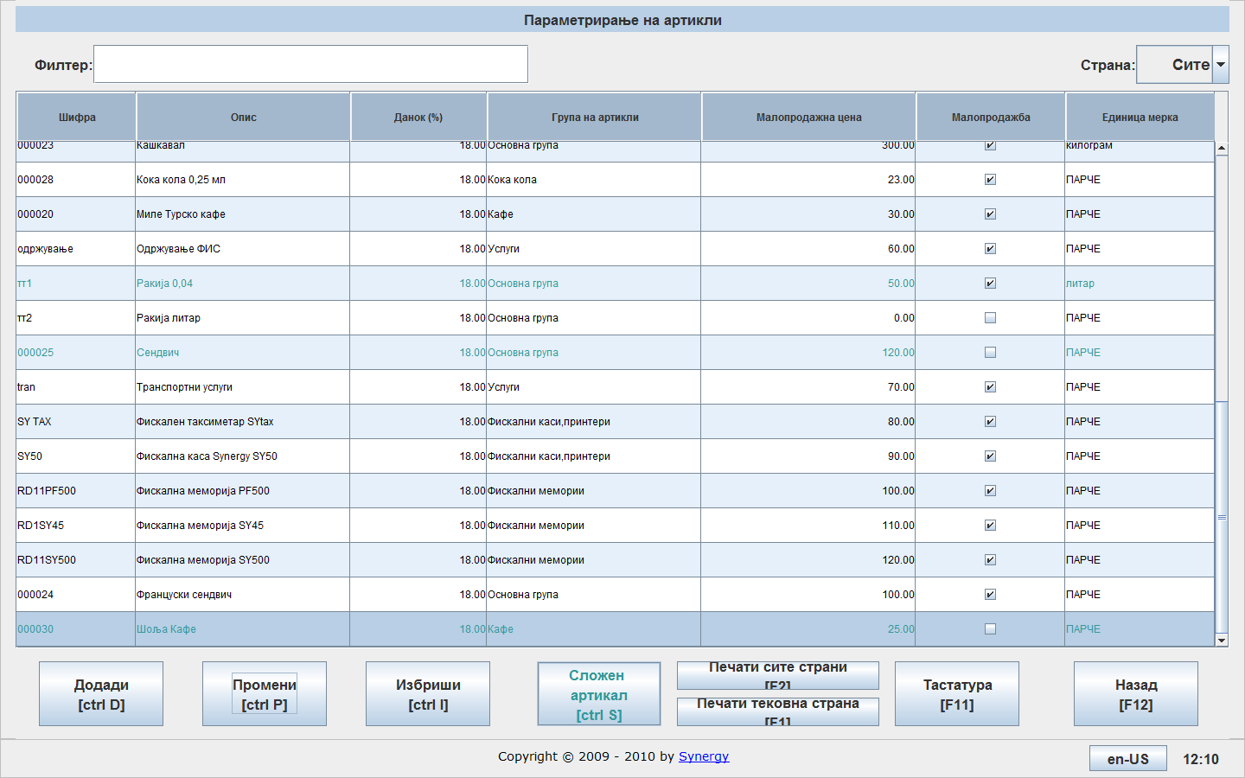

After pressing the button Complex item, it will open the following screen:
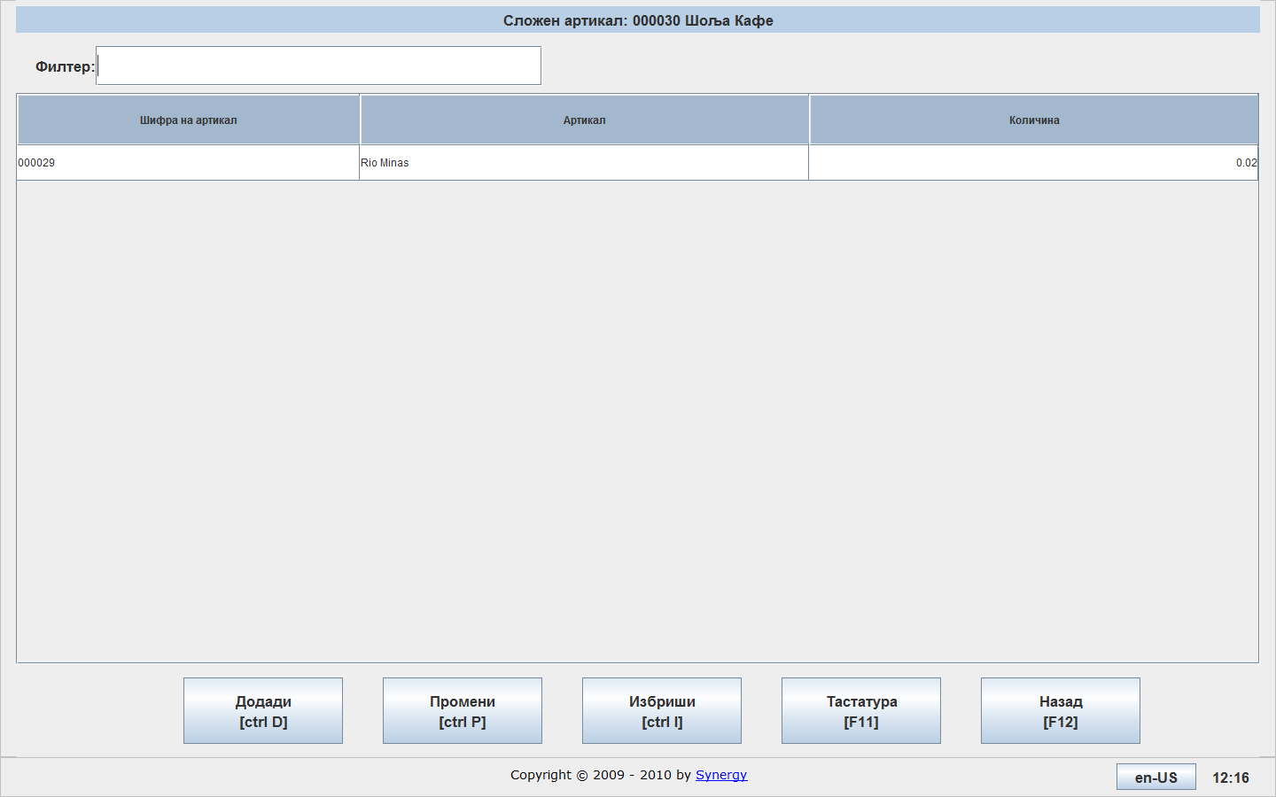
With pressing the button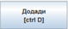, it will open new screen, where you can enter the item and quantity of the item, which are part of that complex item. You can enter items as many as you want for your complex item.
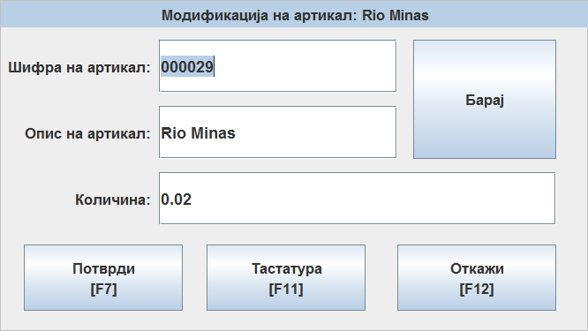

After you have created the complex item, you can sell it, if you have on stock the items which are part of the complex item.
If you want to change some element of the complex item, than you select it and press the button
If you want to delete some element of the complex item, than you select it and press the button
Price List

With pressing the button, it will open the following screen, where you have default options: Add, Change and Delete.
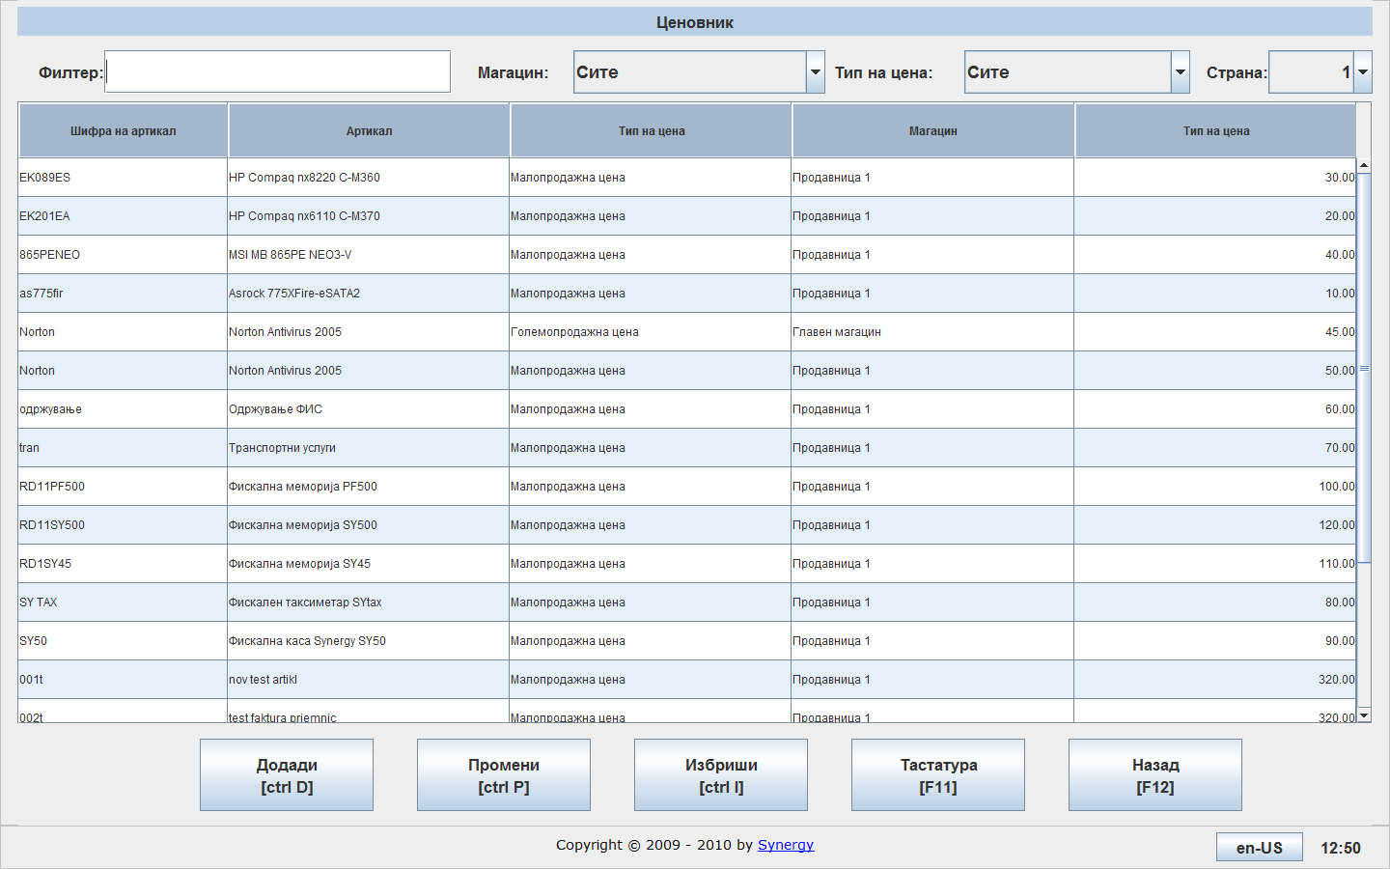

With pressing the button , it you will open the following screen:
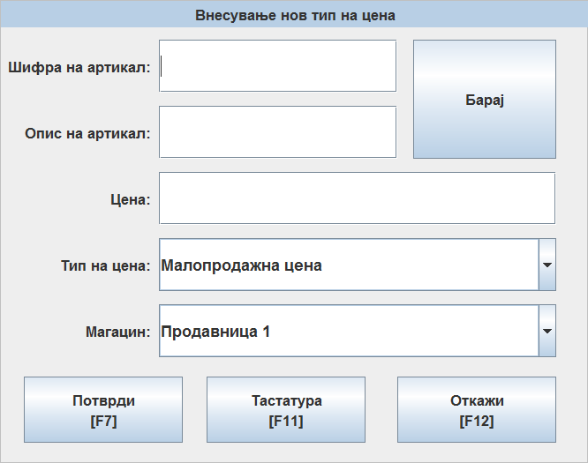
In the field “Code”, you can enter description of the item by your choice, if you want the system to generates code, press the button
In the field “Description” , you can enter description of the item.
In the field “Price” , you can enter price of the item.
In the field “Price Type”, you can enter the type of price, which can be retail price and wholesale price.

In the field “Warehouse”, you can enter for witch warehouse is it the price witch you enter.

With pressing the button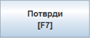, you can confirm the data, and it is creates the price for that item is create.
For one item you can create retail и wholesale price, for each warehouse.
If you want to change some price for the item, you select it ant press the button
If you want to delete some price for the item, select it and press the button

Жиро - сметки
Со притискање на копчето ви се отвара следниов екран, каде што ги имате стандардните опции: Додади, Промени и Избриши.
With pressing the button you can open following screen, where you have default options: Add, Change and Delete.
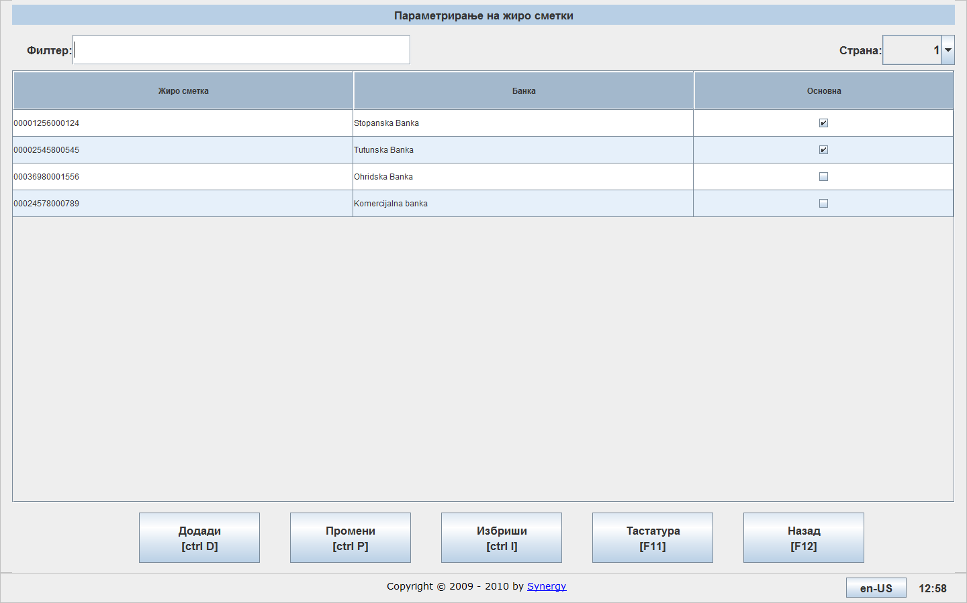
Со притискање на копчето ви се отвара следниов прозорец:
With pressing the button you can open the following screen:
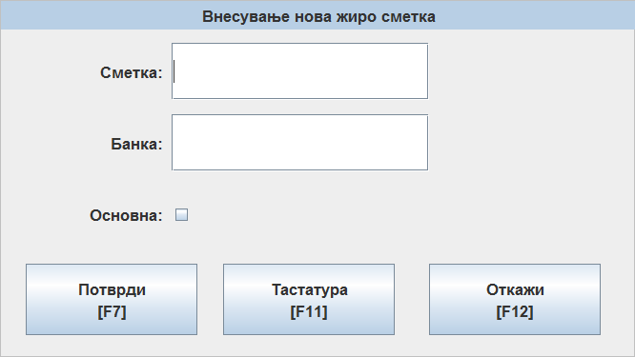
Во полето Сметка ја внесувате банкарската сметка.
In the field “Account” you can enter bank account.
Во полето Банка го внесувате името на банката.
In the field “Bank” you can enter the bank’s name.
Со селекција на полето Основна, кажувате дека ова е основна сметка и ќе се појавува како прва при креирање на некој документ.
If you select the field “Simple”, you can choose this account like default and will appears first when you will create some document.

With pressing the button , you can confirm the data, and it is create new bank account.
If you want to change some bank account, you select the one witch you want to change and pressing the button
If you want to delete some bank account, you select it and press the button

Единици мерки

With pressing the button, it will open the following screen, where you have the default options: Add, Change and Delete.

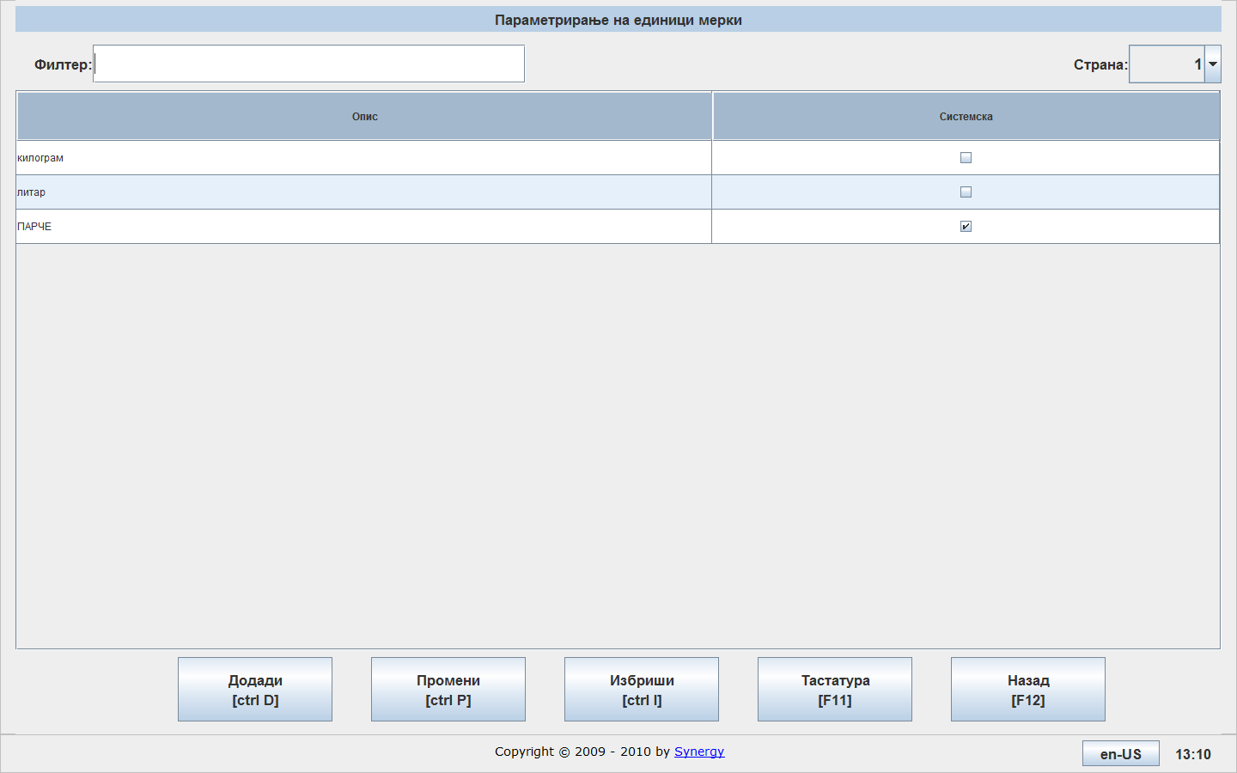

With pressing the buttonit will open the following screen:
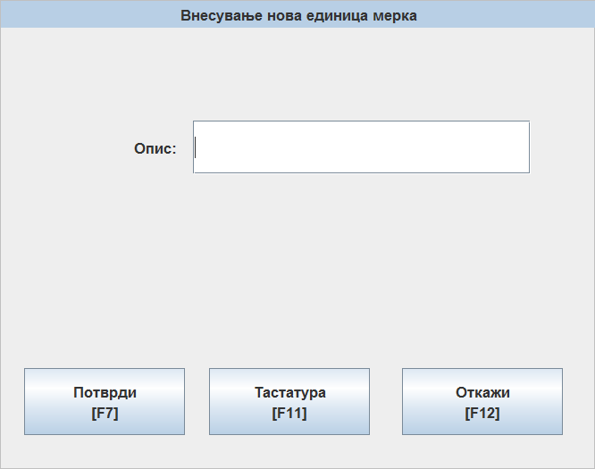
In the field “Description” you can enter description of the measurement.
With pressing the button, you can confirm entering of the data, and it is creates new measurement.
If you want to change some measurement, you can select it and press the button

If you want to delete some measurement, you can select it and press the button.

Users

By pressing the button , it will open the following screen, where you have the default options: Add, Change and Delete.
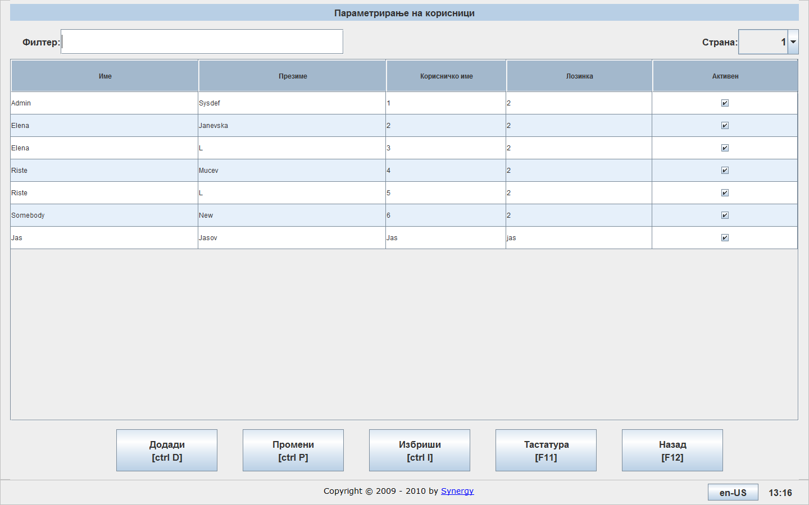
By pressing the button it will open the following screen
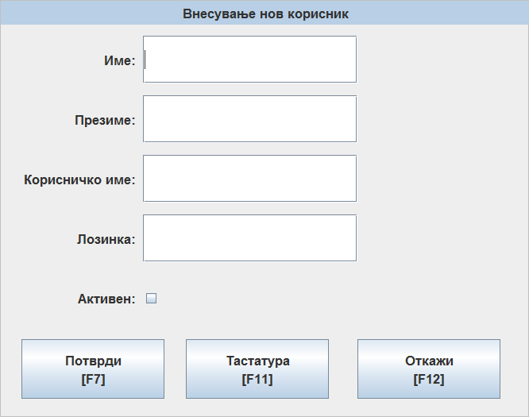

In the field “Name” you can enter name of the user.
In the field “Surname” you can enter surname of the user.
In the field “Username” you can enter user name of the user.

In the field “Password” you can enter password, which the user will needs for login in the system.
With selecting the field active, you choose the user to be active in the system.
By pressing the button, you can confirm data, and it is create new user.
If you want to change some user, you can select it and press the button
If you want to delete some user, you can select it and press the button

Warehouses
With pressing the button, you can add new warehouse, if you need it.
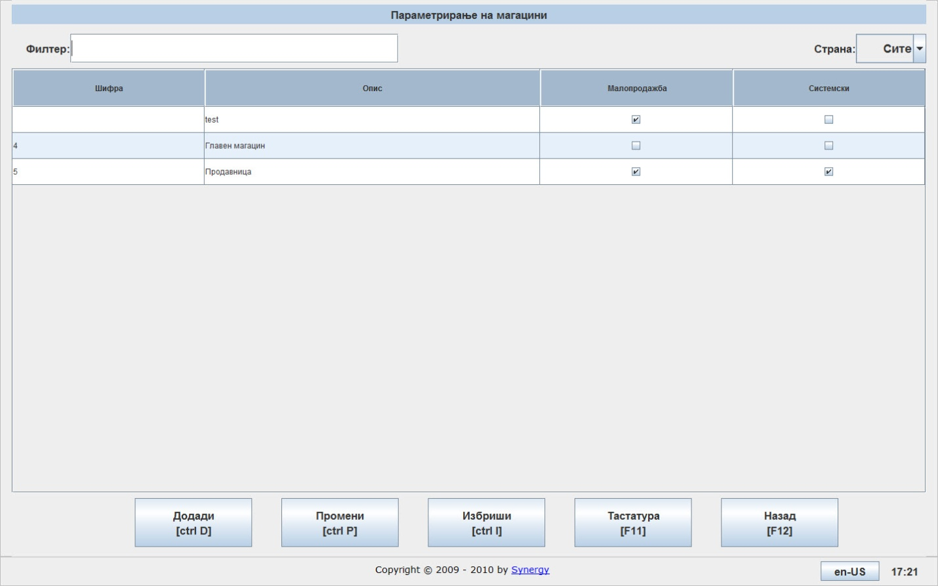

Company
With pressing the button, you can enter data for the company, which have easyPos installation.
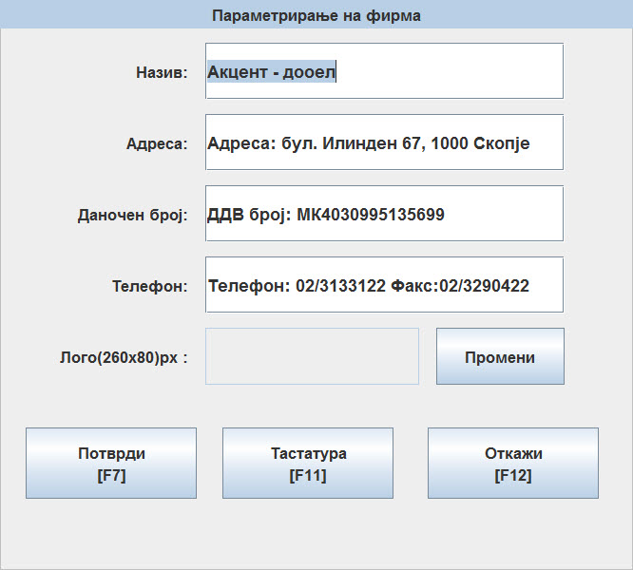

Price types
With pressing the button , you can enter new price types, if you need it.
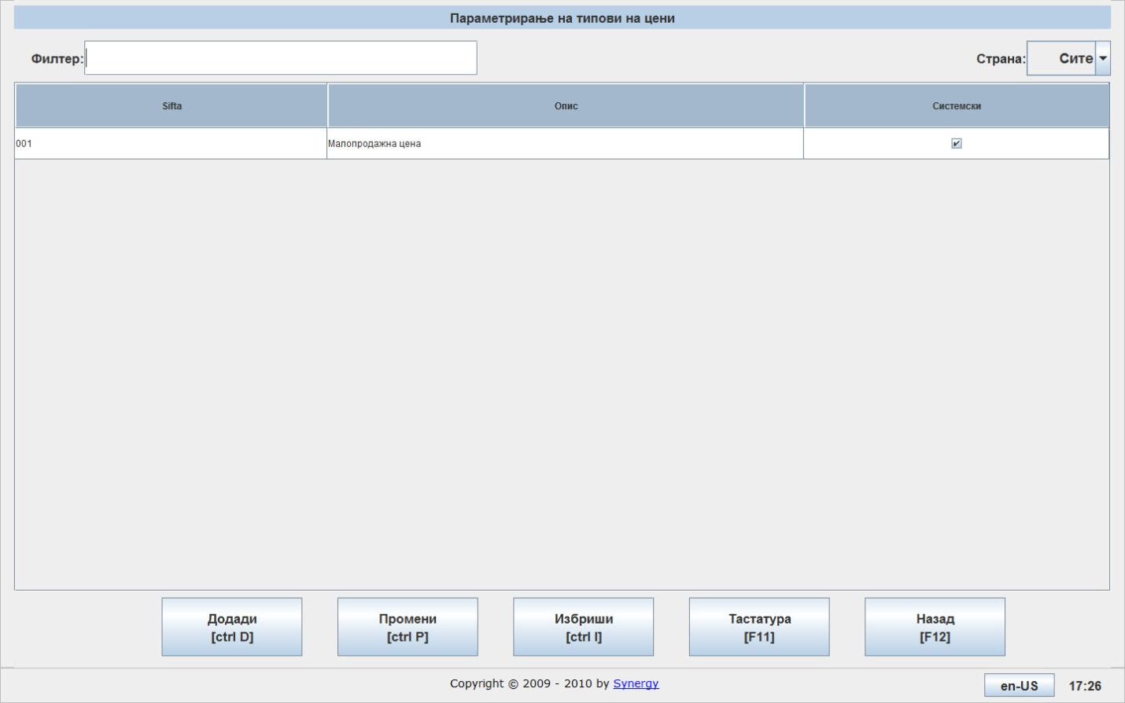

Printer
Easypos allows paramet-parametrirawe of the printer, the access is via main menu and by pressing the button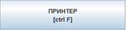
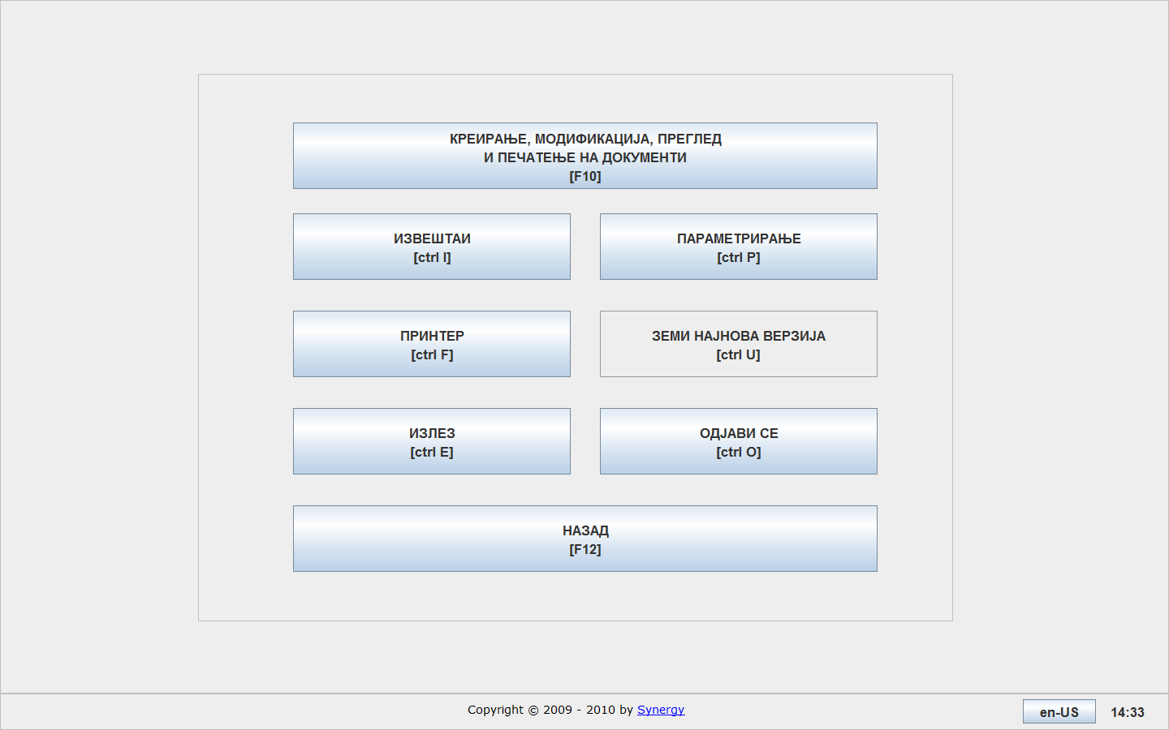

After choosing the option printer, it will open the following screen:
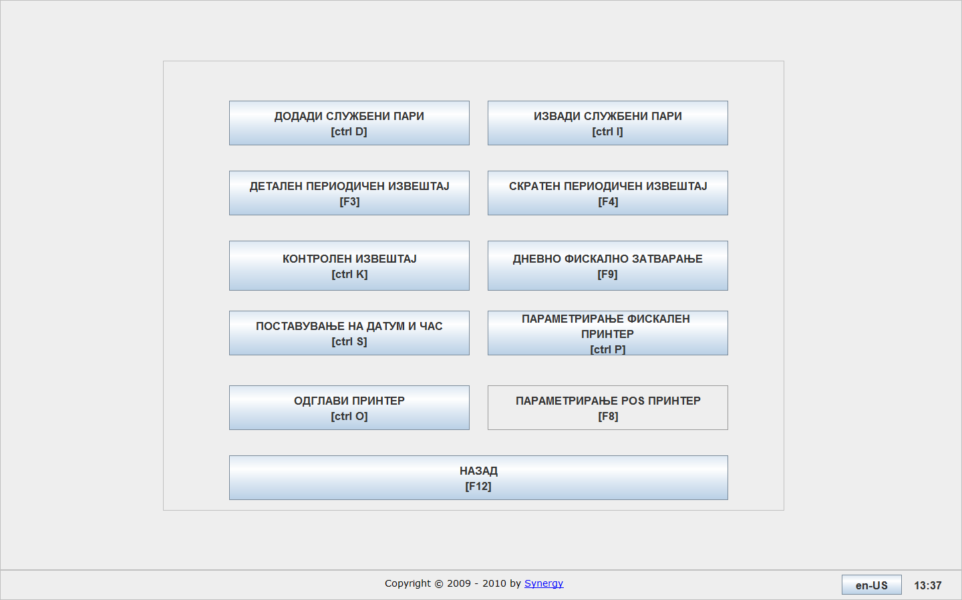
In the field “cash money” you can enter money in the cash register, in the beginning of the day. By pressing the button it will open the following screen:
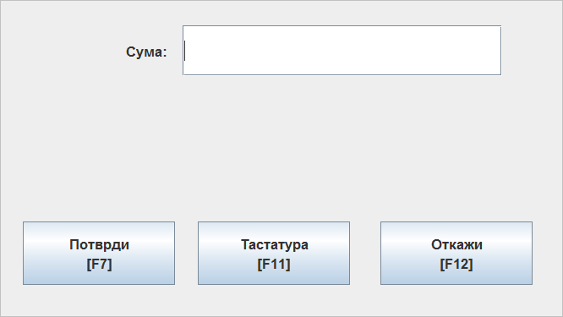
In the field “amount” you can enter the amount in the cash register. By pressing the button Confirm it will open the following screen, where you can confirm your data.
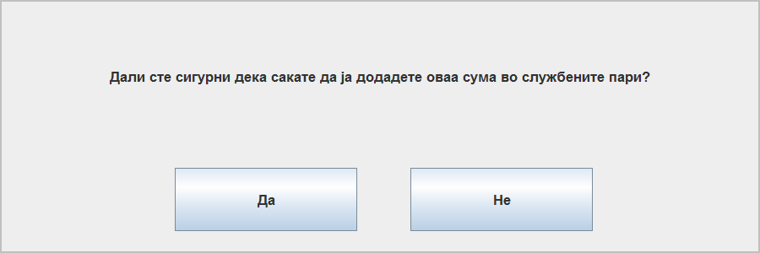
Полето извади службени пари служи за излез на пари од каса на крај на работен ден. Со притискање на копчето ви се појавува следниов прозорец:
In the field cash money get the cash money . By pressing the button will open the following screen
Каде што во полето сума, ја внесувате сумата којашто сакате да ја извадите од каса. Со притискање на копчето Потврди ви се појавува уште еден дијалог прозорец, кадешто треба да го потврдите вашиот внес.
In the field Amount, you can enter the amount which you want to . By pressing the button Confirm will open dialog screen, where you can confirm your data.
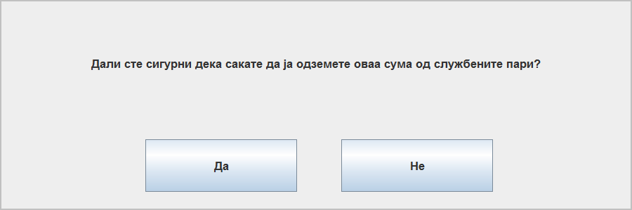

By pressing the button 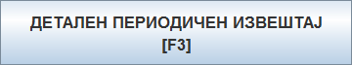you can create detailed periodic report.
By pressing the same button it will open the following screen:
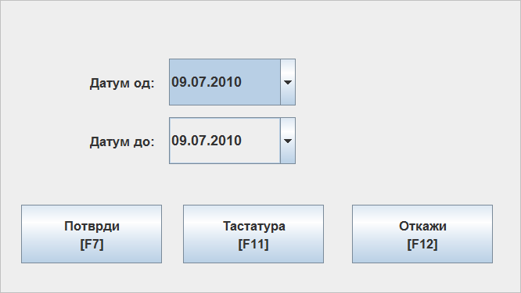
In the field date from and date to you can enter dates, for which be generate this report.

By pressing the button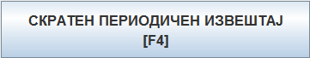, you can create short periodic reports.
By pressing the same button it will open the following screen
Where in the fields date from and date to you can enter dates, for which be generate this report.

By pressing the button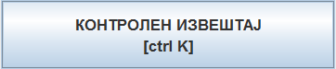 , you can create control reports.
By pressing the same button it will open the following screen
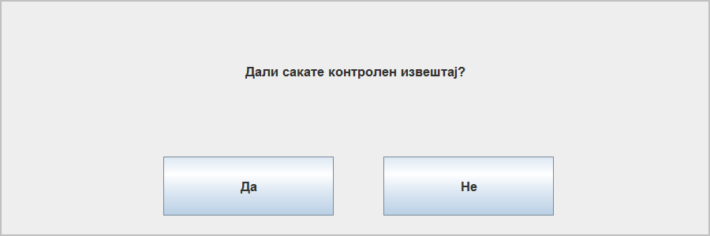

After your confirmation, the printer will print the control repot.
By pressing the button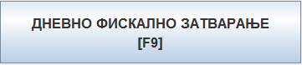, you can create daily fiscal closure.
Доколку не извршите дневно фискално затварање за еден ден, прометот од наредниот ден ќе ви биде прикажан на претходниот ден за којшто не било извршено дневно фискално затварање.
If you don’t run daily fiscal closure, the cash from previous day will be
By pressing the same button it will open the following note:
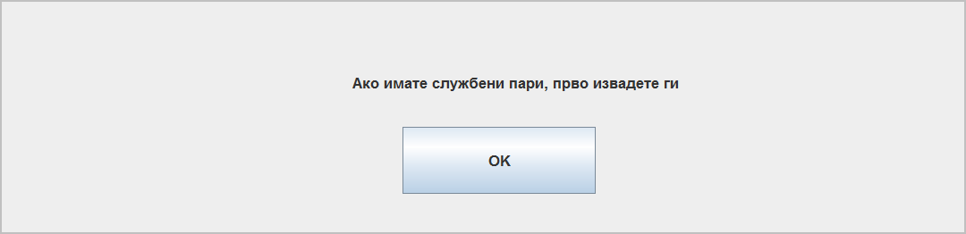

After your confirmation it will open the following screen:
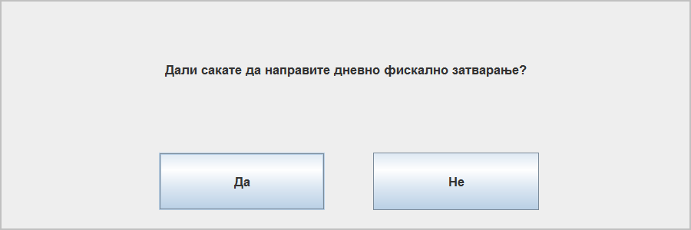
After your confirmation, the system has run the daily fiscal closure.

By pressing the button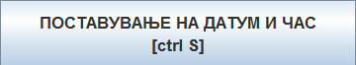, you can set date and time of the printer.
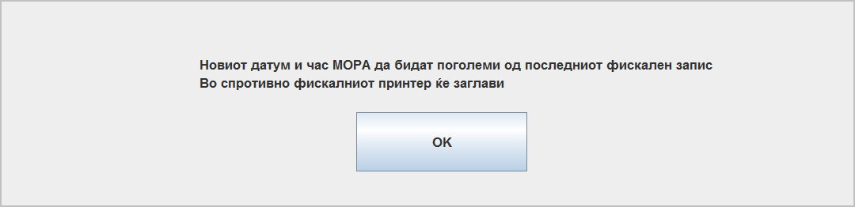
After your confirmation will open the following screen, where you can write new values for date and time.
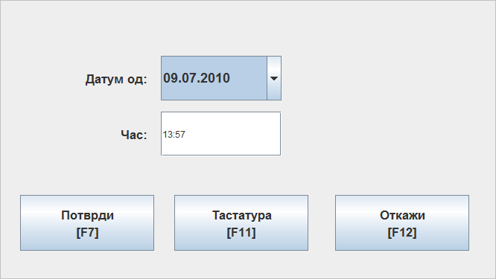

By pressing the button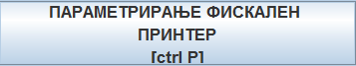 you can define the COM port, which the printer uses to communicate with the computer.
By pressing the same button will open the following screen, where you can write the port, which is uses for communication.
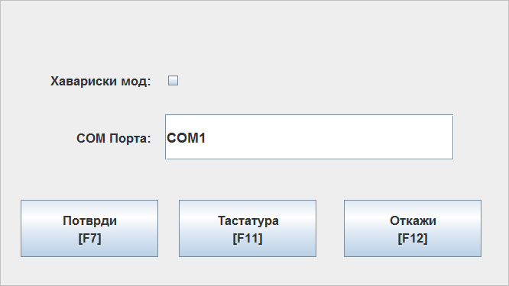
By selecting offline mod, you can include the option for the offline mod.
By pressing the button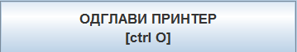, you can unjam the printer, if it has jammed.

